

Master Thesis

**Unsupervised Learning for Activity Recognition in Ambient Assisted Living Environment**

|  |  |
| --- | --- |
| Submitted by: | Mohammad Tanveer Ansari |
| First examiner: | Dominic Gibietz |
| Second examiner: | Prof. Dr. Eicke Godehardt |
| Date of start: | 26.05.2025 |
| Date of submission: | 13.10.2025 |

Statement

I confirm that I, Mohammad Taveer Ansari have written this thesis on my own. All sources used are duly referenced, and any content taken directly or indirectly from published or unpublished sources is properly cited. The figures and drawings included are my own creations or are appropriately referenced. While the core ideas and execution of this work are my own, I utilized tools such as ChatGPT for code debugging and troubleshooting, as well as Quillbot and Grammarly to enhance grammar and textual clarity.

Furthermore, I affirm that this work has not been submitted in the same or a similar form to any other examination board.



13.10.2025

_______________________________

Date, Signature of the Student

Acknowledgement

I would like to express my deepest gratitude to Dominic Gibietz, for his invaluable guidance, insightful feedback, and unwavering support throughout this project. His expertise and encouragement have been instrumental in shaping my ideas and bringing this project to reality.

I also extend my appreciation to everyone who has supported me in this journey.

1 Introduction 7

1.1 Background and Motivation 7

1.2 Problem Statement 8

1.3 Research Objectives 10

1.4 Scope and Limitations 11

2 Background and Literature Review 14

2.1 Human Activity Recognition (HAR) 14

2.2 Sensor-Based HAR 15

2.3 Machine Learning for HAR 15

2.4 Deep Learning Models for Sequential Data 16

2.4.1 Feed-Forward Neural Networks (NN) 16

2.4.2 Recurrent Neural Networks (RNN) 16

2.4.3 Bidirectional Long Short-Term Memory (Bi-LSTM) 16

2.4.4 1D Convolutional Neural Network (1D-CNN) 18

3 Methodology and System Design 20

3.1 Dataset Description 20

3.1.1 Dataset Structure 20

3.1.2 Sensor Types 21

3.1.3 Duration and Scale 21

3.1.4 Dataset Goals 22

3.2 Data Preprocessing 22

3.2.1 Loading and Parsing the Data 23

3.2.2 Filtering Relevant Sensor Data 23

3.2.3 Handling Missing or Incomplete Data 23

3.2.4 Removing Short-Duration Activities (Filtered Later) 23

3.2.5 Sensor State Normalization 23

3.2.6 Activity Label Encoding 24

3.3 Handling Short-Duration Activities 25

3.3.1 Rationale for Filtering Short-Duration Activities 25

3.3.2 Grouping and Filtering Activity Segments 25

3.3.3 Consequences on Model Training 26

3.4 Feature Engineering 26

3.4.1 Sensor Activation Flags 27

3.4.2 Time-of-Day Features 27

3.4.3 Room-Level Spatial Context 27

3.4.4 Light Intensity Measurement 27

3.4.5 Time Since Last Event 28

3.4.6 Day of the Week 28

3.4.7 Overview of Final Feature Set 28

3.4.8 Visual Overview 28

3.5 Sequence Generation 29

3.5.1 Sliding Window Approach 29

3.5.2 Target Label Assignment 30

3.6 Model Architectures 31

3.6.1 Bidirectional LSTM Model 32

3.6.2 1D-CNN Model 33

3.6.3 Neural Network (MLP) Model 34

3.6.4 Baseline/Comparison Models 35

3.6.4.1 Logistic Regression 35

3.6.4.2 Feedforward Neural Network (Shallow MLP) 36

3.6.4.3 Comparison Criteria 36

3.7 Training and Evaluation 37

3.7.1 Training Configuration 37

3.7.2 Evaluation Metrics 38

3.7.3 Model Evaluation and Reporting 39

4 Implementation and Results 40

4.1 Experimental Setup 40

4.1.1 Hardware Configuration 40

4.1.2 Software Environment 40

4.1.3 Dataset Configuration 41

4.2 Evaluation Metrics 42

4.2.1 Confusion Matrix 42

4.2.2 Accuracy 43

4.2.3 Precision 43

4.2.4 Recall (Sensitivity) 43

4.2.5 F1-Score 43

4.2.6 Macro and Weighted Averages 43

4.2.7 Evaluation Process 44

4.3 Experiment 1 – Bidirectional LSTM Results 44

4.3.1 Training and Validation Performance 45

4.3.2 Quantitative Performance 45

4.3.3 Per-Class Evaluation 46

4.3.4 Discussion 47

4.4 Experiment 2 – 1D-CNN Results 47

4.4.1 Training and Validation Performance 47

4.4.2 Quantitative Performance 48

4.4.3 Class-Wise Analysis 49

4.4.4 Discussion 50

5 Discussion 51

5.1 Comparative Analysis of Models 51

5.1.1 Quantitative Comparison 51

5.1.2 Visual Comparison of Accuracy Trends 51

5.1.3 Confusion Matrix Comparison 52

5.1.4 Model Behaviour and Feature Learning 53

5.1.5 Comparative Visualization 53

5.1.6 Key Observations 54

5.2 Error Analysis 54

5.2.1 Common Misclassification Patterns 54

5.2.2 Quantitative Error Trends 55

5.2.3 Discussion and Interpretation 55

5.3 Limitations and Significance of Findings 56

5.3.1 Limitations 56

5.3.2 Significance of Findings 57

6 Conclusion and Future Work 58

6.1 Conclusion 58

6.2 Future Work 59

7 Abbreviations 60

8 References 63

9 Appendix 65

# Introduction

Human Activity Recognition (HAR) in smart environments has become a vital research area, with applications spanning healthcare, elderly support, energy efficiency, and personalized services [3]. As more people adopt Internet of Things (IoT) devices and affordable ambient sensors, smart homes are now producing a wealth of data that reflects the daily routines of their occupants [19]. To create intelligent, responsive, and context-aware systems, it’s crucial to accurately interpret this data to identify activities like cooking, bathing, sleeping, or leaving home. However, the real challenge is transforming raw, event-driven sensor streams into meaningful insights while navigating issues like noisy data, inconsistent labelling, and the high variability among individuals and environments. This thesis aims to develop a robust deep learning-based pipeline for recognizing daily activities from smart-home sensor data. Specifically, it assesses and compares the performance of Bidirectional Long Short-Term Memory (Bi-LSTM) networks and one-dimensional Convolutional Neural Networks (1D-CNN) to find out which architecture is better suited for handling sequential event data in HAR tasks.

## Background and Motivation

Over the last ten years, we've seen an incredible surge in smart home technologies and the Internet of Things (IoT) [4]. Gadgets like motion detectors, light sensors, temperature probes, and door contacts have become commonplace in homes, healthcare facilities, and assisted-living spaces. These sensors are always on, tracking how people interact with their surroundings and creating detailed logs that capture daily habits and behaviours. This extensive collection of sensor data presents significant opportunities for understanding human behaviour in a privacy-preserving manner, a process referred to as Human Activity Recognition (HAR).

The use of HAR in smart homes has really caught people's attention due to its wide array of applications. In the healthcare sector, it allows for remote monitoring of elderly or at-risk individuals, helps in spotting health issues early, and can send out automatic alerts during emergencies. When it comes to energy management, knowing how and when people use different rooms and appliances can lead to better consumption practices and lower costs. In terms of security and personalized services, being able to recognize activities can trigger smart actions, like locking doors on their own, adjusting the lighting, or even suggesting meal options. All these applications have one thing in common: they rely on accurately and promptly recognizing what occupants are doing, even amidst the constant noise from sensor data.

While HAR using ambient sensors holds a lot of potential, it also comes with its fair share of challenges [3]. For starters, sensor events tend to be sparse and not evenly spaced out over time. Take activities like “Cooking” or “Watching TV,” which can stretch on for several minutes or even hours; the related sensor events, like motion or light changes, happen in just milliseconds or seconds, resulting in fragmented signals. Additionally, activity patterns can vary widely from person to person and even from day to day, making it tough to establish fixed rules. On top of that, annotated datasets often suffer from inconsistent or incomplete labels, which adds another layer of complexity to supervised learning. To tackle these hurdles, a model is needed that can effectively capture long-term temporal dependencies, handle noise, and adapt to a variety of contexts.

In the early days of Human Activity Recognition (HAR), researchers often leaned on handcrafted features and simpler machine learning techniques like Decision Trees, Naïve Bayes, Support Vector Machines, and Hidden Markov Models [3]. While these methods had the advantage of being interpretable, they often fell short when it came to capturing the complexities of temporal dynamics and overlapping activities. On the other hand, deep learning has shown incredible promise in areas like speech recognition, machine translation, and video analysis, all of which deal with sequential data [5].

In the HAR domain, two deep learning architectures are particularly promising:

* Bidirectional Long Short-Term Memory (Bi-LSTM) networks take the classic LSTM model a step further by processing sequences in both forward and backward directions. This unique approach allows them to capture dependencies that stretch over long intervals and aren’t strictly causal [7]. This feature is particularly useful for sensor data, where the significance of an event can hinge on both past and future contexts.
* On the flip side, one-dimensional Convolutional Neural Networks (1D-CNNs) shine when it comes to identifying local temporal patterns and hierarchical features from raw sequential data. They’re not only computationally efficient but also have fewer parameters compared to recurrent networks, making them a great choice for real-time applications.

While both architectures have been used for Human Activity Recognition (HAR) independently, there's a noticeable gap in research that directly compares them using real-world, event-driven smart home datasets that include annotated activities. Most of the existing studies tend to focus on wearable sensors like accelerometers and gyroscopes, or they rely on synthetic datasets that feature clean segmentation [19]. However, event-driven ambient sensor data is quite different; it tends to be sparse, noisy, and often has variable-length gaps.

This thesis is driven by the need to thoroughly assess which deep learning model, Bi-LSTM or 1D-CNN works better for identifying daily activities from smart home sensor data. This work puts together a full system, starting from raw data, then cleaning and formatting it to create sequences. After that, it trains two models using the same settings. This setup lets the work give advice to those working on HAR, helping them pick the right model setup for actual uses.

Additionally, the study tackles practical challenges like dealing with inconsistent annotations, aggregating events into meaningful time frames (for instance, activities that last more than five minutes), and finding the right balance between model accuracy and computational efficiency. Ultimately, our goal is not just to enhance recognition accuracy but also to showcase a reproducible methodology that can be adapted to other sensor-rich environments.

In summary, the background and motivation for this research lie at the intersection of three key trends:

1. The growing availability of smart-home sensor data.
2. The limitations of traditional HAR methods in handling sparse, irregular, and noisy sequences [3].
3. The need to compare state-of-the-art deep learning models (Bi-LSTM and 1D-CNN) on realistic datasets to guide future research and deployment.

By tackling these issues, the thesis contributes to advancing the state of human activity recognition and supporting the development of intelligent, context-aware smart environments.

## Problem Statement

The rise of Internet of Things (IoT) devices in our homes has led to a massive influx of sensor data that reflects how we go about our daily lives. A prime example is the CASAS smart home dataset, which is one of the most popular open research resources out there. It includes event logs from various ambient sensors like motion detectors, door contacts, light sensors, and temperature probes. These sensors track how occupants interact with their living spaces, but they do it in a roundabout way: rather than directly recording activities, they produce time-stamped events (like “M001 ON” or “LS010 48”) that need to be deciphered.

Identifying broader activities such as “Cooking,” “Sleeping,” “Bathing,” or “Leaving Home” from these raw sensor data streams is quite a challenge for a number of reasons:

* **Irregular, high-frequency events:** When individual sensors register ON/OFF events, they do so just milliseconds or seconds apart, but the actual activity they’re tracking might stretch on for minutes or even hours. This mismatch in timing leads to fragmented signals, making it tough to pin down a single activity label.
* **Noisy and incomplete annotations:** Even in well-organized datasets like CASAS, you might find that activity labels aren’t consistently applied across all sensor events. Sometimes, different activities overlap or get mislabelled, which adds another layer of complexity to supervised learning [1].
* **Context-dependent patterns:** Take, for instance, the same sensor event, it could represent different activities based on the context. For example, “Kitchen Motion ON” could indicate either “Cooking” or “Cleaning,” depending on what happened before or after that event.
* **Model selection uncertainty:** While deep learning has shown potential for handling sequential data, there’s still not enough solid evidence to determine which architecture—Bidirectional Long Short-Term Memory (Bi-LSTM) networks or one-dimensional Convolutional Neural Networks (1D-CNNs)—is more effective for this kind of sparse, event-driven ambient sensor data. [5].

A lot of the previous research on Human Activity Recognition (HAR) has been centred around wearable sensors like accelerometers and gyroscopes. These devices provide a steady and regular stream of data, which makes it easier to use traditional sequence models [3]. On the flip side, smart-home sensors operate differently, generating sparse and asynchronous events. As a result, the models and feature engineering methods that perform well with wearable data might not translate effectively to the data from ambient sensors.

Given this context, the central problem addressed by this thesis is:

This study focuses on creating and testing a deep learning system. The system will identify human behaviours from sensor data in the CASAS dataset. The work will deal with issues like sensor errors, timing gaps, and labelling problems.

To tackle this, several sub-problem**s** arise:

1. **Data preprocessing and segmentation**

Dealing with raw event logs and turning them into useful sequences can be tricky, mainly when activity labels are not constant or blur together. A good example is dealing with several ON/OFF events that happen in milliseconds. How these can be grouped into time frames that show activities lasting over five minutes?

1. **Feature representation**

Consideration also needs to be made on what features to extract from motion and light sensor events. The goal is to provide enough temporal and contextual information to the model without getting bogged down in excessive hand-engineering?

1. **Model architecture comparison**

When it comes to deep learning models, which one performs better for this type of data: Bi-LSTM or 1D-CNN? And what conditions influence their performance? It’s important to understand how model complexity and computational efficiency balance out against accuracy?

1. **Evaluation methodology**

Another key point is how to fairly compare these models, especially given the imbalanced distribution of activities. Performance needs to be measured in a way that goes beyond just overall accuracy, looking at metrics like per-class precision and recall, as well as confusion matrices.

Tackling these sub-problems is essential for creating reliable Human Activity Recognition (HAR) systems in real-world smart environments. If these issues is not addressed, any system that is deployed could suffer from poor performance, false alarms, or missed detections, which would ultimately erode user trust and diminish the potential benefits, such as health monitoring or energy optimization.

In summary, the focus of this thesis is to develop an end-to-end pipeline that processes raw CASAS event logs, segments them into meaningful sequences, and trains and evaluates both Bi-LSTM and 1D-CNN models to classify high-level activities that last at least five minutes. By systematically comparing these two architectures under the same conditions, this study aims to shed light on the strengths and weaknesses of each approach for ambient sensor-based HAR.

## Research Objectives

The main goal of this thesis is to create a strong, deep learning-based system for recognizing human activities (HAR) by utilizing ambient motion and light sensor data from the CASAS smart-home dataset. It also aims to thoroughly assess how effective two sequence-based architectures are: Bidirectional Long Short-Term Memory (Bi-LSTM) networks and one-dimensional Convolutional Neural Networks (1D-CNNs). By concentrating on activities that last at least five minutes, this research intends to minimize noise interference and enhance recognition accuracy in real-life situations.

The specific research objectives are as follows:

1. **Preprocessing and Activity Segmentation**
   * Develop a preprocessing pipeline to tidy up and organize the raw CASAS sensor logs.
   * Break down continuous sensor events into significant activity sequences, combining multiple ON/OFF events from sensors into windows that correspond to activities lasting five minutes or more.
   * Tackle inconsistencies and missing annotations in the dataset to ensure a reliable ground truth for supervised learning.
2. **Feature Engineering for Ambient Sensor Data**
   * Identify and pull out key features from motion and light sensor events, such as event counts, time indicators (hour, minute, second), room occupancy, and metrics based on duration.
   * Create sequence representations that are perfect for deep learning models, making sure to capture both short-term trends and long-term dependencies.
3. **Model Development and Comparison**
   * Use a Bi-LSTM model to understand long-range temporal dependencies in the sequential sensor data, taking advantage of both past and future contexts.
   * Employ a 1D-CNN model to detect local temporal patterns and hierarchical features from sequences of sensor events.
   * Compare both models based on classification accuracy, F1-score, confusion matrices, training efficiency, and how well they generalize.
4. **Evaluation and Validation**
   * Divide the dataset into training, validation, and test sets to thoroughly assess model performance.
   * Use techniques to address class imbalance and ensure a fair comparison between the models.
   * Examine misclassifications and pinpoint where each model excels or struggles.
5. **Practical Implications and Guidelines**
   * Offer insights on which architecture is better suited for real-time Human Activity Recognition (HAR) applications using ambient sensors.
   * Provide practical recommendations for implementing deep learning-based HAR systems in smart homes, taking into account computational efficiency, resilience to noise, and adaptability to various home layouts or occupants.

This thesis sets out to achieve some important goals: it aims to make scientific contributions by systematically comparing Bi-LSTM and 1D-CNN architectures for sparse, event-driven Human Activity Recognition (HAR), while also providing practical insights through a reproducible pipeline for recognizing activities in real-world smart homes. Ultimately, the study wants to show that deep learning models, when paired with careful preprocessing and feature engineering, can effectively identify significant activities from ambient sensors. This capability opens up exciting possibilities in healthcare, assisted living, and context-aware services.

## Scope and Limitations

The focus here is on developing and assessing a deep learning-based HAR system that utilizes data from ambient motion and light sensors, specifically drawn from the CASAS smart home dataset. The research scope is intentionally narrow to ensure that the study remains practical and reproducible, all while tackling the main challenges of event-driven activity recognition.

**Scope**

1. **Data Source**
   * The study relies solely on CASAS datasets, which feature time-stamped events from various ambient sensors set up in real residential environments. These datasets come with ground truth activity labels, making supervised learning and model evaluation possible.
   * Only motion (M) and light (LS) sensors are included in the analysis. Other sensor types, like temperature, door locks, and battery status, are left out to keep things simple and to concentrate on the most relevant ambient signals for activity recognition.
2. **Activity Selection**
   * The thesis focuses exclusively on high-level daily activities, such as cooking, bathing, sleeping, and entering or leaving the home, along with other significant routines.
   * Activities that last less than five minutes are filtered out to eliminate transient events and minimize label noise, ensuring that the models are trained on sustained, meaningful activity sequences.
3. **Deep Learning Models**
   * Two deep learning architectures are implemented and evaluated:
     + Bidirectional LSTM (Bi-LSTM) to capture long-term temporal dependencies in sensor sequences.
     + One-dimensional Convolutional Neural Networks (1D-CNNs) to learn local temporal patterns and hierarchical representations.
   * Classical machine learning models (e.g., Decision Trees, SVMs) are not explored, as the focus is on comparing sequence-based deep learning architectures suitable for event-driven data.
4. **Evaluation Metrics**
   * Models are assessed using standard classification metrics: accuracy, precision, recall, F1-score, and confusion matric**es**.
   * Experiments include train-validation-test splits and address class imbalance using weighting techniques.
5. **Implementation Context**
   * The study emphasizes reproducibility and practical application. Preprocessing scripts, sequence generation pipelines, and trained models are designed to be extensible to other CASAS datasets or similar smart home environments.

**Limitations**

While this thesis aims to provide robust HAR solutions, certain limitations are acknowledged:

1. **Dataset Specificity**

The models rely exclusively on CASAS data for both training and evaluation. This means that differences in how sensors are placed, the layout of homes, or how people behave in other smart homes could impact how well the models generalize.

1. **Sensor Type Restriction**

Only motion and light sensors are utilized in this study. Other potentially useful sensors, like those measuring temperature, appliance usage, or door contacts, were left out. While adding these sensors could enhance activity recognition, it wasn't part of this research's focus.

1. **Activity Labeling Issues**

Even though activities are labelled in CASAS, some of those labels might not be consistent or complete. By filtering out activities that last less than five minutes, the noise can be reduced, but it does not completely eliminate it.

1. **Real-Time Deployment**

The models are assessed offline using pre-recorded datasets. This thesis does not tackle real-time deployment issues, such as latency, handling streaming events, or hardware limitations.

1. **Model Complexity and Interpretability**

Deep learning models, particularly Bi-LSTM, can demand a lot of computational power. Additionally, their decision-making processes are often less transparent than those of traditional models, which could be a drawback in healthcare settings where understanding the reasoning behind decisions is crucial.

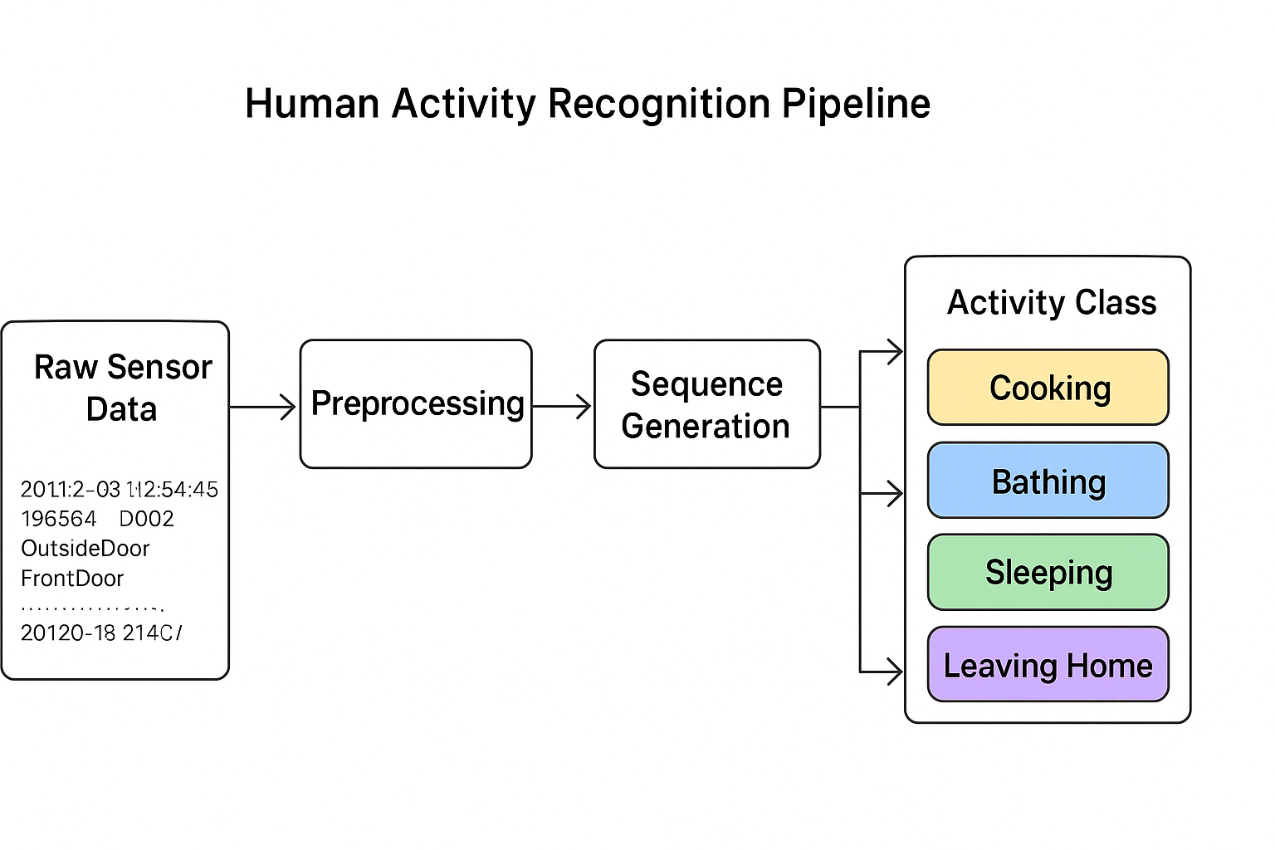Despite these challenges, this study offers important insights into temporal sequence modeling for Human Activity Recognition (HAR). It showcases how Bi-LSTM and 1D-CNN architectures handle sparse, event-driven sensor data and sets up a reproducible pipeline that can be built upon in future research.

Figure 1.1: Overview of the Human Activity Recognition pipeline showing the process from CASAS sensor data to Bi-LSTM and 1D-CNN classification

Figure 1.1 provides a clear overview of the Human Activity Recognition (HAR) system that I've developed in this thesis. It all starts with continuous sensor readings from the CASAS smart-home environment, which capture motion, light, and various other environmental factors. The first step is to pre-process these raw signals to eliminate any noise, synchronize timestamps, and filter out irrelevant sensor events. Once that is done, important features like the ON/OFF patterns of the sensors, the duration of activities, and the context of their locations is extracted, transforming this information into sequential data windows. These sequences are then input into two deep learning models which is Bidirectional Long Short-Term Memory (Bi-LSTM) and one-dimensional Convolutional Neural Network (1D-CNN). These are trained to identify patterns linked to specific activities, such as cooking, sleeping, or bathing. In the end, the models generate activity predictions, which is evaluated and compared using accuracy, confusion matrices, and other performance metrics. This pipeline effectively demonstrates how diverse sensor data can be converted into meaningful, high-level activity labels through sophisticated deep learning methods.

# Background and Literature Review

This chapter lays the groundwork for the research by diving into both the theoretical and empirical aspects. It explores the idea of Human Activity Recognition (HAR), the various sensors involved, and how machine learning and deep learning models play a crucial role in HAR. Additionally, it touches on the latest research trends, especially focusing on Bi-LSTM and 1D-CNN architectures, while also pointing out the gaps in existing literature that this thesis seeks to fill.

## Human Activity Recognition (HAR)

Human Activity Recognition (HAR) refers to the automatic identification and classification of human actions or behaviours using sensor data [3]. This concept has become increasingly important with the rise of smart homes, wearable technology, and Internet of Things (IoT) systems. HAR has a wide range of applications, including:

* Healthcare monitoring (like detecting falls or unusual behaviour in elderly patients)
* Smart homes (for energy efficiency, security, and personalized services)
* Workplace safety (monitoring employee movements to avoid accidents)
* Sports and fitness (tracking workouts and activity levels)

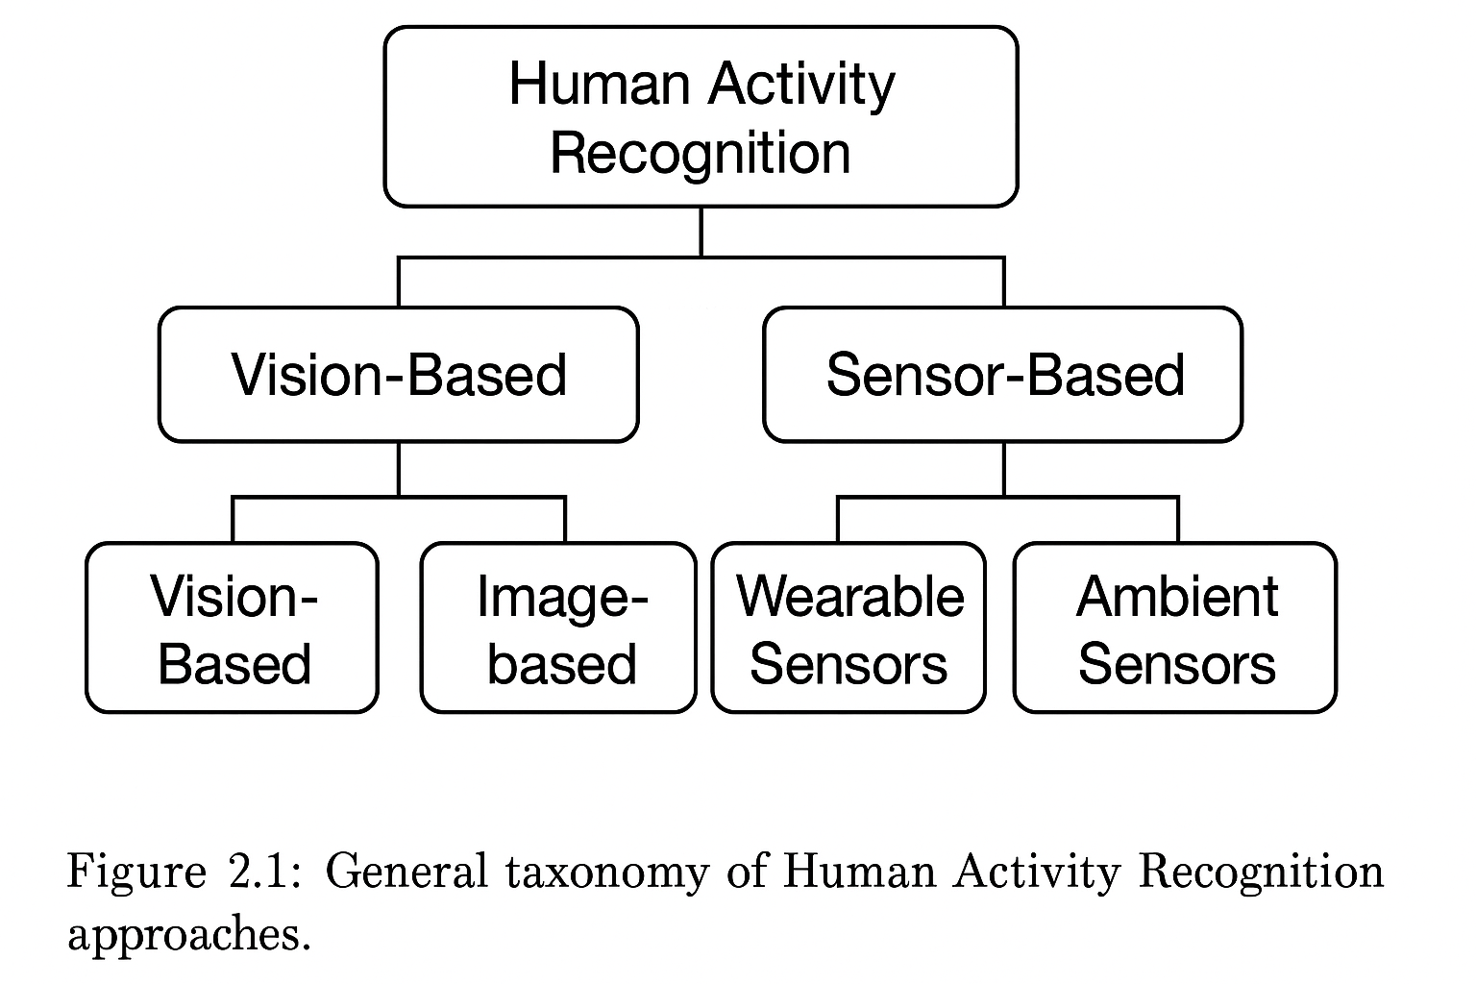 In the early days, HAR systems were largely based on rule-based methods, where human experts set specific thresholds or sequences of sensor events. However, with the rise of machine learning, HAR has evolved into data-driven models that can learn intricate patterns from extensive datasets [3].

Figure 2.1: General taxonomy of Human Activity recognition

This figure can show two main branches that is “Vision-based HAR” and “Sensor-based HAR” with examples under each.

## Sensor-Based HAR

Although HAR has made extensive use of computer vision techniques (CCTV, RGB-D cameras), sensor-based HAR offers clear benefits, particularly in settings where privacy is a concern, such as smart homes. Typically, sensor-based HAR makes use of:

* **Environmental sensors**: motion sensors (M), light sensors (LS), pressure mats, door sensors.
* **Wearable sensors**: accelerometers, gyroscopes, heart rate monitors.

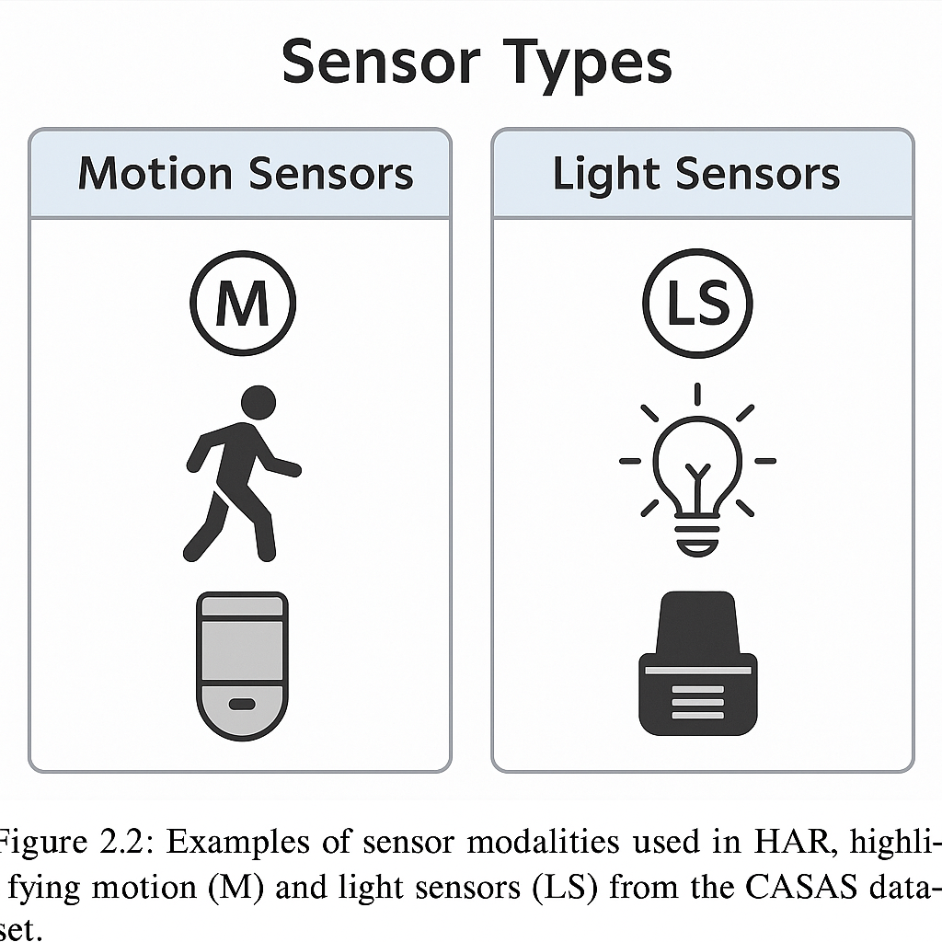The CASAS dataset serves as a prime example of how environmental sensors can be used for Human Activity Recognition (HAR). It collects data on motion, light, and other contextual elements from a real home, allowing researchers to observe everyday activities without the need for intrusive cameras.

Figure 2.2: Sensor modalities used in HAR

Figure 2.2 showsexamples of sensor modalities used in HAR, highlighting motion (M) and light sensors (LS) from the CASAS dataset*.*

## Machine Learning for HAR

In the realm of HAR, traditional machine learning models like Decision Trees, Support Vector Machines (SVM), Hidden Markov Models (HMM), and Random Forests have been quite popular. These models generally rely on:

* Feature engineering, which involves extracting both time-domain and frequency-domain features
* Windowing techniques that break continuous data streams into fixed-length segments
* Labelling, where each segment is associated with a specific activity

While traditional methods do well with simple activities, they often have trouble with long-term patterns. This is especially true for sensor data like that from the CASAS dataset.

Table 2.1: General Structure of a Master or Bachelor thesis

|  |  |  |
| --- | --- | --- |
| **Model** | **Strengths** | **Limitations** |
| Decision Trees | Interpretable, fast training | Limited to simple decision boundaries |
| SVM | Handles high-dimensional data | Difficult to tune kernels |
| HMM | Good for sequential modeling | Assumes Markov property, poor for long-term dependencies |
| Random Forest | Robust to noise, non-linear | Does not model temporal order |

## Deep Learning Models for Sequential Data

Recent advances in deep learnin**g** have transformed HAR by automatically learning features from raw sensor data. Two key classes of models dominate:

1. Recurrent Neural Networks (RNNs**)** – designed for sequential data.
2. Convolutional Neural Networks (CNNs) – adapted for time-series signals.

### Feed-Forward Neural Networks (NN)

Feed-forward neural networks (or Multi-Layer Perceptrons – MLPs) form the simplest deep learning models. However, they treat input features as independent and fail to exploit temporal dependencies inherent in sequential data.

### Recurrent Neural Networks (RNN)

RNNs were designed to manage sequential data by keeping a hidden state throughout different time steps. Unfortunately, standard RNNs struggle with vanishing and exploding gradient issues, which makes them less effective for processing long sequences, like multi-minute activity traces in CASAS.

### Bidirectional Long Short-Term Memory (Bi-LSTM)

LSTM networks tackle these gradient problems by incorporating memory cells and gating mechanisms—specifically, input, forget, and output gates. A Bidirectional LSTM takes it a step further by analyzing the sequence in both forward and backward directions, allowing the model to capture context from both the past and the future at the same time. This is particularly beneficial in Human Activity Recognition (HAR), where knowing about future sensor events can clarify current activities.

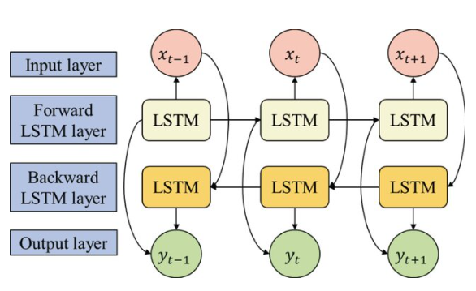Figure 2.3: Architecture of a Bidirectional LSTM model used for sensor-based HAR [27].

The accompanying diagram should illustrate the input sequences, the forward and backward LSTM layers, and the output classification layer.

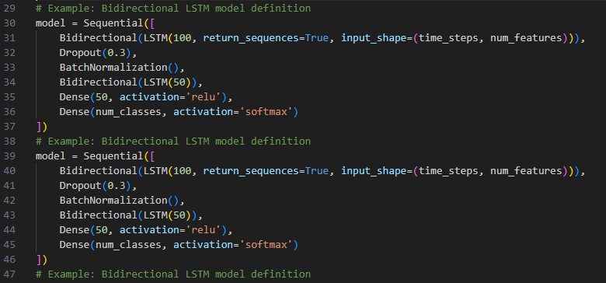To show how Bidirectional LSTMs can be applied in HAR, low-level TensorFlow version of the model is created as implemented in Figure 2.4

Figure 2.4: TensorFlow implementation of a Bi-LSTM model for HAR.

The code snippet above outlines a training loop for a Bidirectional LSTM applied to CASAS data, showcasing the model architecture and its training process discussed in this section.

### 1D Convolutional Neural Network (1D-CNN)

Originally created for image processing, CNNs can also be adapted for time-series data by utilizing 1D convolutional filters. These 1D-CNNs are capable of extracting local temporal patterns (similar to n-grams in text) and have demonstrated impressive performance in HAR, especially when paired with pooling and dense layers.

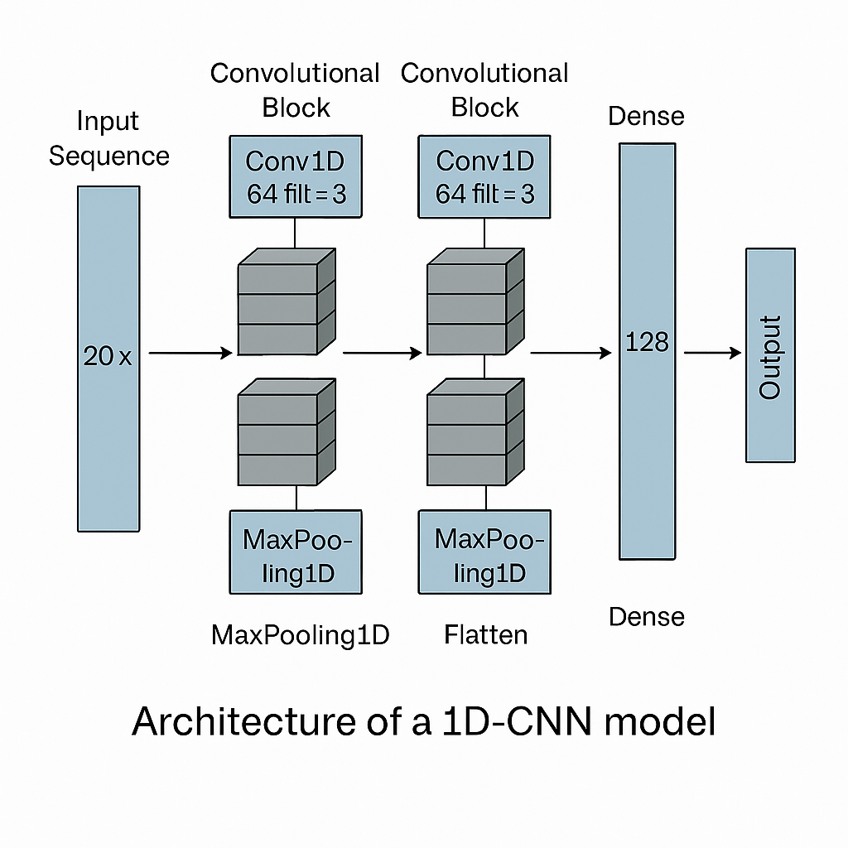

Figure 2.5: Architecture of the 1D-CNN model

This figure can depict multiple convolutional blocks, pooling layers, and the final dense layers.

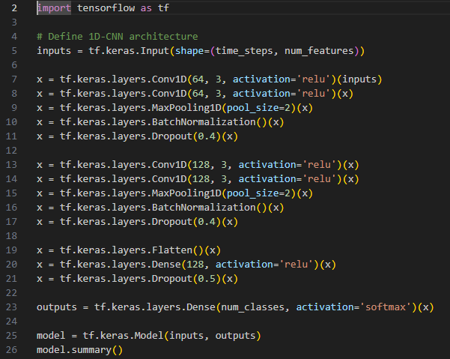Figure 2.6: TensorFlow implementation of a 1D-CNN model for HAR.

Figure 2.6 depicts the 1D-CNN model was implemented similarly using the TensorFlow API.

# Methodology and System Design

This chapter dives into the methodology used to create a robust and dependable human activity recognition (HAR) system, leveraging ambient sensor data from a smart home setting. The approach combines real-world data collection, data cleaning, temporal filtering, feature engineering, and cutting-edge deep learning models for classification. Every step in this methodology has been thoughtfully crafted to enhance predictive performance while ensuring that the results remain interpretable and reproducible.

To achieve it, publicly available smart home datasets is utilized from the CASAS project, which provide minute-by-minute details of sensor activities linked to labelled human actions. These datasets are organized, cleaned up, and transformed into sequences that capture the temporal relationships necessary for sequential learning models like Bi-LSTM and 1D Convolutional Neural Networks (1D-CNN).

## Dataset Description

This research taps into sensor data from the CASAS Smart Home project, created by the Centre for Advanced Studies in Adaptive Systems at Washington State University. The dataset serves as a valuable resource of annotated ambient sensor data gathered from a real smart home environment, specifically designed for activity recognition studies. The selected dataset, hh101, features densely packed sensor events over several weeks, documenting the daily indoor activities of an individual.

### Dataset Structure

The dataset comes as a plain text file named hh101.ann.txt, formatted with tab-delimited values. Each row corresponds to a specific sensor activation event and includes metadata such as the timestamp, sensor identifier, message type, and activity annotation. The dataset encompasses the following fields:

|  |  |
| --- | --- |
| **Field Name** | **Description** |
| DateTime | Timestamp of the sensor event |
| Sensor | Sensor ID (e.g., M001, LS001, etc.) |
| Translate01 | Primary sensor location or mapping |
| Translate02 | Secondary location/mapping if applicable |
| Message | Status or value reported (e.g., ON, OFF, or light value) |
| SensorType | Type of the sensor (e.g., Control4-Motion, LightSensor) |
| Activity | Labeled human activity (e.g., Cooking, Sleeping) |

The example of sample data as per the above field is given below in Table 3.1

Table 3.1: Sample Data

|  |  |  |  |  |  |  |
| --- | --- | --- | --- | --- | --- | --- |
| DateTime | Sensor | Translate01 | Translate02 | Message | SensorType | Activity |
| 2012-07-20 10:38:54.512364 | M001 | OutsideDoor | Entry | ON | Control4-Motion | Step_Out |
| 2012-07-20 10:38:54.653634 | LS001 | Ignore | Ignore | 49 | Control4-LightSensor | Step_Out |
| 2012-07-20 10:38:59.541365 | M001 | OutsideDoor | Entry | OFF | Control4-Motion | Step_Out |

This structure allows us to extract temporal features, sensor states, and activity labels for sequential modelling using deep learning architectures.

### Sensor Types

The CASAS environment is equipped with a diverse range of sensors, including:

* **Motion Sensors (M):** These binary sensors let us know if someone is present by using simple ON and OFF signals.
* **Light Sensors (LS):** They provide continuous readings of light intensity (like 48, 76).
* **Temperature Sensors (T):** Used to monitor room temperature.
* **Door Sensors (D):** Triggered when doors are opened or closed.
* **Battery Sensors (BATP):** Report device battery percentages.

For this study, focus is on Motion and Light sensors because they have a strong link to changes in activity and real-time movements between different indoor spaces.

Table 3.2: Sensor Inclusion

|  |  |  |  |
| --- | --- | --- | --- |
| **Sensor Prefix** | **Sensor Type** | **Included** | **Reason** |
| M | Motion Sensor | Yes | High relevance to activity |
| LS | Light Sensor | Yes | Correlates with environment |
| D | Door Sensor | No | Sparse and redundant |
| T | Temperature Sensor | No | Low variability over time |
| BATP | Battery Sensor | No | Not activity-relevant |

By narrowing the focus, the noise can be eliminated in the training data and highlight the features that are most likely to influence how human activity is inferred.

### Duration and Scale

The dataset covers several weeks, capturing the natural ebb and flow of behaviour over time. It boasts a high resolution, with multiple sensor activations recorded within just a second during active periods.

Key characteristics include:

* **Total number of events:** ~1.4 million
* **Sensors used:** 30–60 (depending on room layout)
* **Event frequency:** sub-second level (high frequency)
* **Activity labels:** Annotated as Cooking, Sleeping, Bathing, Step_Out, etc.
* **Duration of activities:** From seconds to several hours (filtered later for ≥5 min)

To keep the model relevant, the dataset is further filtered to include only activity windows that last at least 5 minutes, as detailed in Section 3.3 on Handling Short-Duration Activities.

### Dataset Goals

The main aim of using the CASAS dataset is to train machine learning and deep learning models to automatically recognize human activities based on sequences of sensor data. Accurately identifying activities like Cooking, Sleeping, and Step_Out is crucial for applications such as:

* Elderly care monitoring
* Health and wellness assessment
* Context-aware smart homes
* Ambient intelligence systems

With timestamped sensor data at available, engage and processing in time-series modeling can be possible, making this dataset perfect for Bi-LSTM, and 1D Convolutional Neural Network (CNN) architectures.

Figure 3.1 Human Activity Recognition Pipeline — from raw sensor data to activity classification using deep learning

## Data Preprocessing

Before training any machine learning model on sensor data, the data needs to be cleaned, filtered, and transform the raw dataset into a structured format that is ready for temporal modelling. In this context, preprocessing refers to the series of steps that turn messy, unstructured sensor data into high-quality inputs for Bi-LSTM and 1D-CNN models.

Given the high frequency and variety of sensors in the CASAS dataset, preprocessing is a crucial step that significantly impacts the reliability, accuracy, and robustness of the final activity recognition model. This section outlines the various preprocessing stages applied to the hh101.ann.txt dataset, which include parsing, filtering, addressing missing values, and correcting activity labels.

### Loading and Parsing the Data

The CASAS dataset is stored in a .txt file with tab-separated columns. The first step is to load the data into a structured DataFrame using Pandas. During parsing accurately interpret datetime formats and ensure that the sensor metadata aligns properly with the activity labels.

**import** pandas **as** pd  
  
df = pd.read_csv("./hh101/hh101.ann.txt", sep="\t", header=None, engine='python')  
df.columns = ["DateTime", "Sensor", "Translate01", "Translate02", "Message", "SensorType", "Activity"]  
df["DateTime"] = pd.to_datetime(df["DateTime"], format='mixed', errors='coerce')  
df.dropna(subset=["DateTime"], inplace=True)

This code helps eliminate any malformed timestamps and ensures the dataset is organized chronologically. The engine='python' argument is used to avoid any parsing issues that might arise from inconsistent formatting.

### Filtering Relevant Sensor Data

Only keep sensors that provide valuable contextual information for activity recognition, specifically, the Motion (M) and Light Sensor (LS). Other sensors, like Door, Battery, and Temperature, are left out due to their limited relevance or redundancy.

df = df[df["Sensor"].str.startswith(("M", "LS"))].copy()  
df = df.sort_values("DateTime")

This filtering process helps reduce noise and ensures that only significant behavioural events are included in the sequence generation pipeline.

### Handling Missing or Incomplete Data

Sometimes, sensor events may have missing activity labels or incorrect timestamps. For missing Activity values, forward-filling (ffill) is used based on the assumption that ongoing actions persist until a different label interrupts them.

df['Activity'] = df['Activity'].ffill()  
df.dropna(subset=["Activity"], inplace=True)

This operation ensures that each sensor event can be assigned a label, which is essential for training supervised models.

### Removing Short-Duration Activities (Filtered Later)

Some actions in the data are quite short, lasting just a few seconds. This makes it hard to model time-based patterns well. To fix this, very short actions are removed during the data cleaning stage, as explained in Section 3.3. Data sections that were at least five minutes long is considered for the study.

### Sensor State Normalization

Sensor signals vary by type:

* Motion sensors report binary states: "ON" or "OFF"
* Light sensors report integer light intensity values

To make everything ready for numerical processing, derived binary columns is created that indicate motion activation and the presence of light sensors.

df["motion_on"] = ((df["Sensor"].str.startswith("M")) & (df["Message"] == "ON")).astype(int)  
df["light_event"] = df["Sensor"].str.startswith("LS").astype(int)

These columns will eventually be included in the feature vector for each timestep in our input sequence.

### Activity Label Encoding

Next, convert the string-based activity labels (like "Cooking" and "Sleeping") into numeric values using label encoding, so they can work with deep learning models. Then the LabelEncoder is used from Scikit-learn to create these integer representations.

**from** sklearn.preprocessing **import** LabelEncoder  
activity_encoder = LabelEncoder()  
df["ActivityCode"] = activity_encoder.fit_transform(df["Activity"])

This mapping can be reversed and is maintained throughout the entire process, allowing us to decode predictions during evaluation.

Table 3.3: Sample encoded activity mapping

|  |  |
| --- | --- |
| **Activity** | **Encoded Value** |
| Cooking | 0 |
| Sleeping | 1 |
| Step_Out | 2 |
| Bathing | 3 |

The comprehensive preprocessing pipeline guarantees that the input data is organized chronologically, labelled semantically, and structured numerically, which is essential for consistent and accurate sequence modelling.

The complete sequence of operations from ingesting raw data to label encoding—is shown in the diagram below.

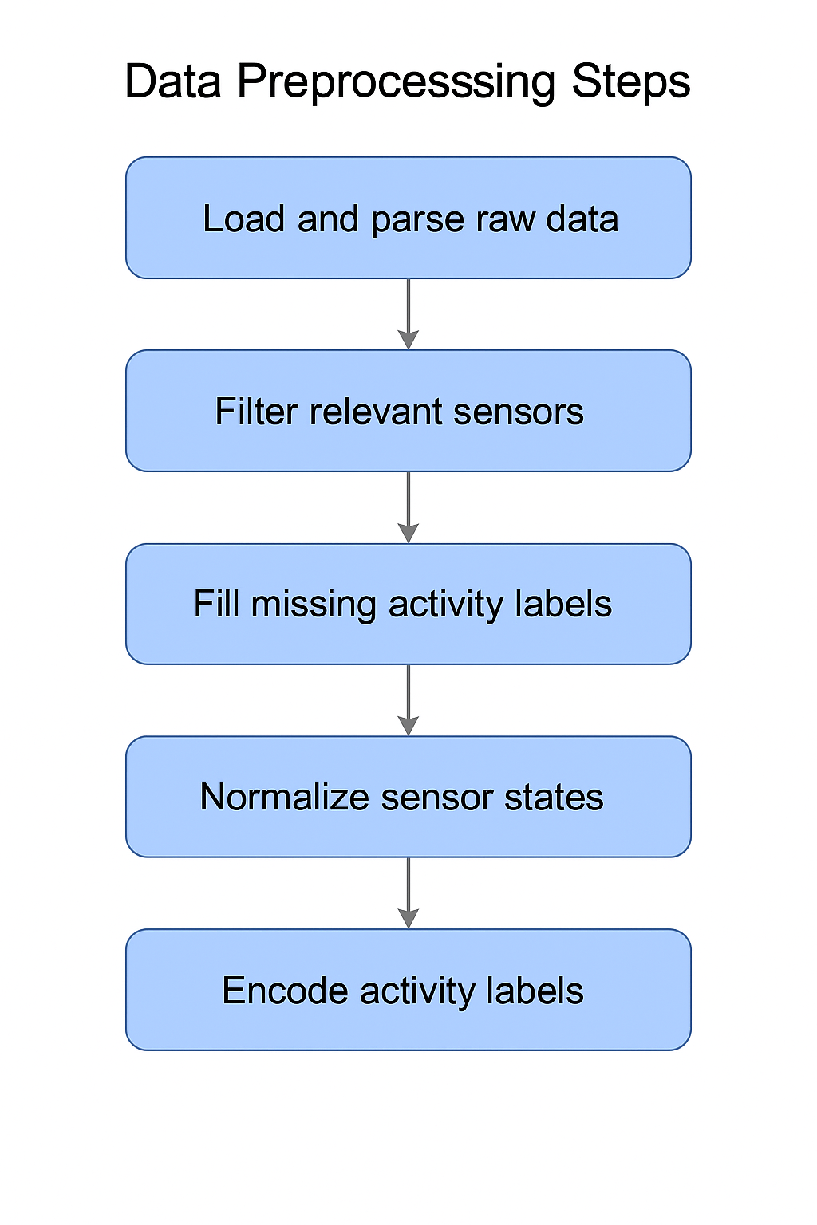

Figure 3.2 Data Preprocessing Pipeline

The flowchart provides a clear overview of the key steps in the preprocessing workflow, including file parsing, sensor filtering, motion and light extraction, and activity label encoding.

## Handling Short-Duration Activities

In the realm of sensor-based Human Activity Recognition (HAR), the raw logs from sensors often capture activities that last only a brief moment—anywhere from just a few milliseconds to a couple of minutes. These fleeting events usually stem from quick movements (like someone walking past a sensor) or even sensor noise, and they often does not accurately represent the true beginning or end of a significant activity (think cooking, bathing, or sleeping).

When training deep learning models on these short, noisy snippets, it can lead to misleading patterns, poor generalization, and a drop in classification performance. That’s why it’s crucial to sift through the dataset and keep only those well-defined activity windows, especially those that last longer than 5 minutes, since sustained human actions are more likely to provide meaningful context.

### Rationale for Filtering Short-Duration Activities

Short-duration activity segments present several issues:

* **Lack of temporal patterns**: Activities such as "Cooking" or "Sleeping" generally involve patterns that unfold over several minutes. A quick 3-second burst of motion simply can’t capture the essence of these tasks.
* **Data imbalance**: Adding in those micro-events can inflate the number of samples for sporadic or unclear activities, which can create class imbalance.
* **Ambiguity in transitions**: Short, unlabelled transitions (like walking from one room to another) might overlap with actual activities and throw the model off track.

To enhance model accuracy and cut down on label noise, the dataset is filtered to keep only those activity segments that last at least 300 seconds (5 minutes).

### Grouping and Filtering Activity Segments

The filtering process involves grouping together sequential rows where the activity label stays the same. Each group is seen as a continuous segment of a specific activity. Then calculate the duration of each group and discard any that does not meet the threshold, as illustrated in the code snippet below.

df['Activity'] = df['Activity'].ffill()  
df.dropna(subset=["Activity"], inplace=True)  
  
# Create a group whenever the activity label changes  
df['activity_group'] = (df['Activity'] != df['Activity'].shift()).cumsum()  
  
# Compute duration of each group in seconds  
activity_durations = df.groupby('activity_group')['DateTime'].agg(  
 **lambda** x: (x.iloc[-1] - x.iloc[0]).total_seconds()  
)  
  
# Retain only segments lasting 5 minutes or more  
valid_groups = activity_durations[activity_durations >= 300].index  
filtered_df = df[df['activity_group'].isin(valid_groups)].copy()

To get a clearer picture of this process, take a look at the diagram below. It shows how short activity segments are filtered out while keeping the longer ones for training.

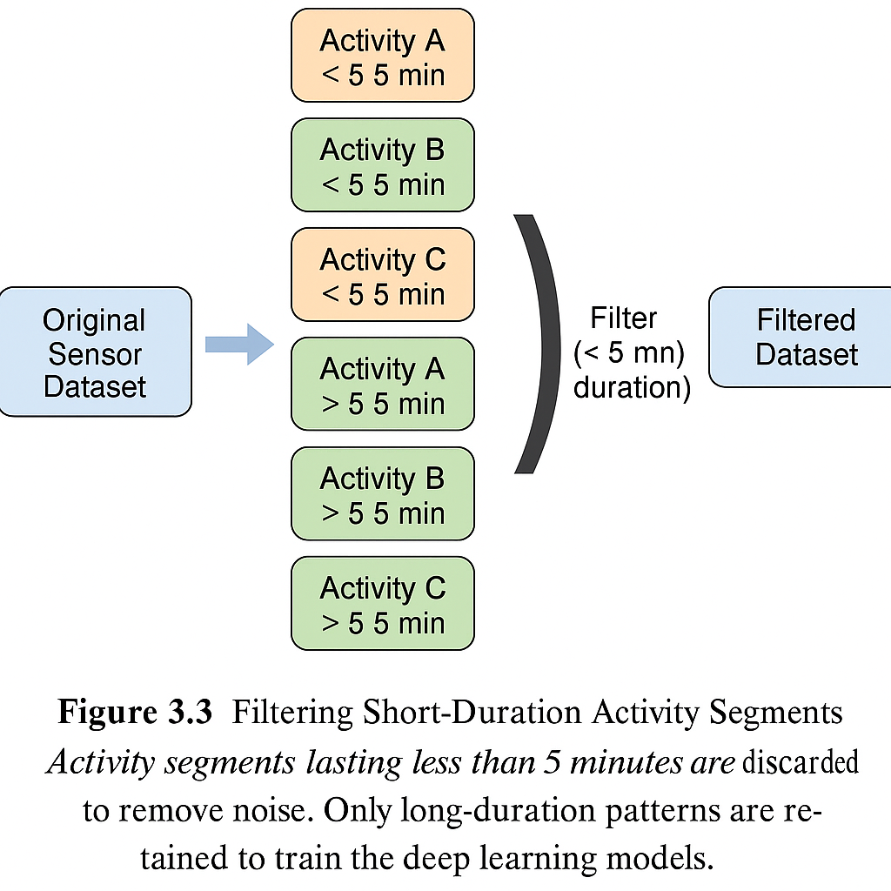

Figure 3.3Filtering Short-Duration Activity Segments

This filtering not only shrinks the dataset but also enhances its quality and relevance. It ensures that we only pass along data that truly matters for the sequence modelling stages.

Table 3.4: Comparison of dataset statistics before and after filtering out short-duration activities.

|  |  |  |
| --- | --- | --- |
| **Metric** | **Value Before Filtering** | **Value After Filtering** |
| Total Sensor Events | 150,000+ | ~80,000 |
| Unique Activity Labels | 12 | 12 |
| Avg. Activity Segment Length | ~30 seconds | ~6 minutes |

### Consequences on Model Training

By leaving out those brief activity segments, several benefits are achieved:

* **Improved Accuracy**: The models can concentrate on significant temporal patterns.
* **Reduced Overfitting**: The model eliminates the noisy, fast-changing activity labels.
* **Stability**: Training becomes more reliable, especially for long-term repetitive behaviours like sleeping, cooking, or working.

## Feature Engineering

Feature engineering is quite important for changing raw sensor data into a format that deep learning models can use. The CASAS data offers time-stamped sensor data, but it lacks ready-made numerical or contextual features for deep learning. Thus, this work designs features to get at the timing, location, and sensor details that define human actions.

In this study, the feature engineering was based on previous work in Human Activity Recognition (HAR) and adjusted for the CASAS dataset's specific structure and meaning. What follows is a detailed look at the features that came up with, including sensor types, time-related information, environmental readings, and category codes.

### Sensor Activation Flags

The main signals in CASAS data come from motion sensors (marked with "M") and light sensors (marked with "LS"). Binary activation flags were added to the feature set to improve input data usability and consistency:

* **motion_on**: This is set to 1 when a motion sensor detects movement and sends an ON message.
* **light_event**: This is set to 1 when a light sensor is activated.

These flags help the model differentiate between various physical events without needing to rely on the sensor names.

filtered_df["motion_on"] = (  
 (filtered_df["Sensor"].str.startswith("M")) & (filtered_df["Message"] == "ON")  
).astype(int)  
  
filtered_df["light_event"] = filtered_df["Sensor"].str.startswith("LS").astype(int)

### Time-of-Day Features

To capture daily activity patterns, time-of-day features I encoded using sine and cosine transformations. This approach helps maintain circular continuity, meaning that times like 23:59 and 00:00 are treated as being close together.

filtered_df['hour_sin'] = np.sin(2 * np.pi * filtered_df['DateTime'].dt.hour / 24.0)  
filtered_df['hour_cos'] = np.cos(2 * np.pi * filtered_df['DateTime'].dt.hour / 24.0)

These two features give us a normalized view of time across a 24-hour period.

### Room-Level Spatial Context

Each sensor is linked to a specific location, such as the Kitchen, Bathroom, or Living Room, based on the Translate01 or Translate02 fields. new categorical feature called "room" is introduced.

filtered_df['room'] = filtered_df['Translate01'].where(  
 filtered_df['Translate01'] != 'Ignore',  
 filtered_df['Translate02']  
)

This addition aids the model in understanding the spatial relationships between activities and how different rooms are used.

### Light Intensity Measurement

For light sensors (LS), the Message field often includes a numeric value that indicates light intensity, extract and standardize this value.

filtered_df['light_value'] = pd.to_numeric(filtered_df['Message'], errors='coerce').fillna(0)  
filtered_df.loc[filtered_df['Sensor'].str.startswith('M'), 'light_value'] = 0

This number can provide insights into environmental conditions tied to specific activities, like higher light levels during the day or while cooking.

### Time Since Last Event

To account for gaps in sensor activity (like long periods of inactivity), calculate the seconds that have passed since the last event. This is especially helpful for distinguishing between short bursts of activity and longer stretches of inactivity.

filtered_df['time_since_last_event'] = filtered_df['DateTime'].diff().dt.total_seconds().fillna(0)  
filtered_df['time_since_last_event'] = filtered_df['time_since_last_event'].clip(upper=3600)

Limit this to 1 hour to prevent skewing the feature distribution due to overnight lulls.

### Day of the Week

Human routines are often influenced by the day of the week (think weekends versus weekdays). It is added as a categorical feature:

filtered_df['day_of_week'] = filtered_df['DateTime'].dt.dayofweek # 0 = Monday

It is then one-hot encoded before being fed into the model.

### Overview of Final Feature Set

The final feature set includes both numerical and categorical inputs, structured as follows:

|  |  |  |
| --- | --- | --- |
| **Feature Name** | **Type** | **Description** |
| motion_on | Binary | Motion sensor activation |
| light_event | Binary | Light sensor event |
| light_value | Numerical | Light intensity level |
| hour_sin, hour_cos | Cyclical | Time-of-day representation |
| time_since_last_event | Numerical | Seconds since previous sensor event |
| day_of_week | Categorical | Day of week (0–6) |
| room | Categorical | Room/location of sensor |

### Visual Overview

Take a look at this visual representation of the engineered features derived from the raw CASAS logs:

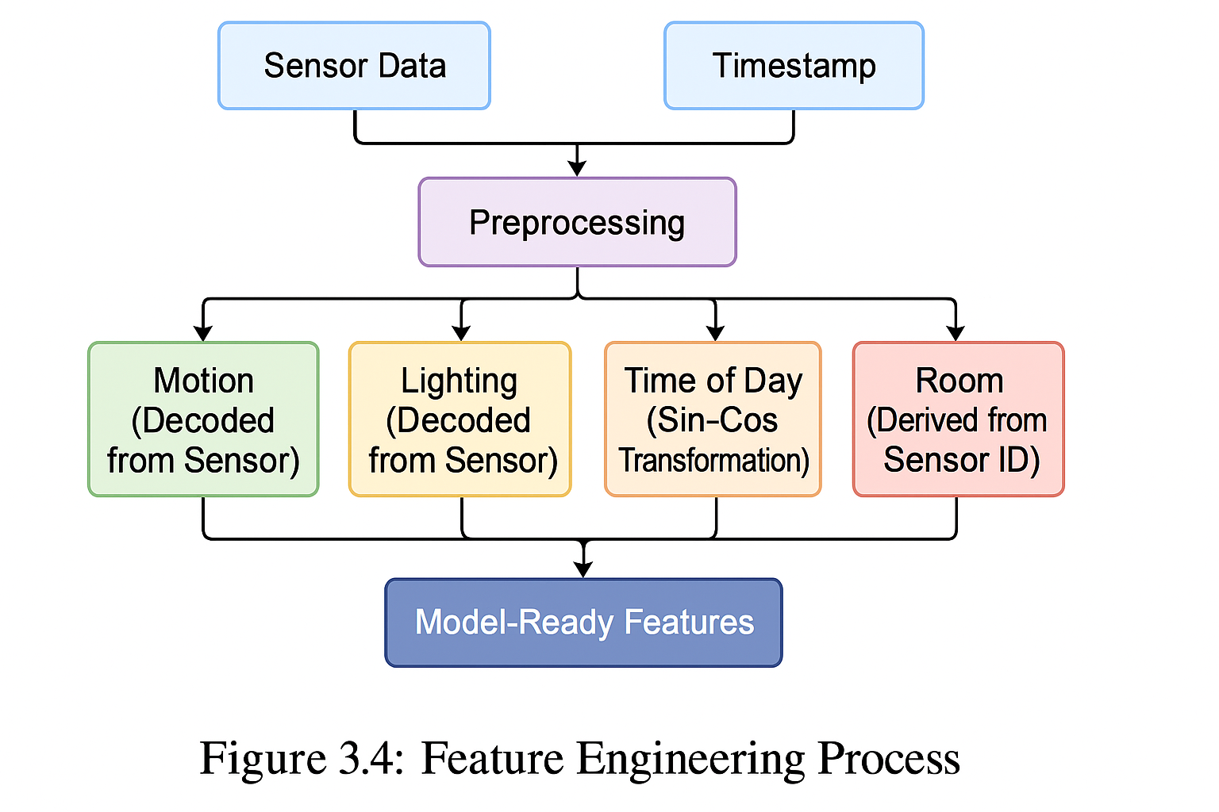

Figure 3.4Feature Engineering Process.

Figure 3.4 illustrates how raw sensor events are parsed and expanded into a structured feature matrix that captures binary states, time context, environment, and location.

## Sequence Generation

In the realm of sensor-based human activity recognition (HAR), deep learning models like LSTM and 1D-CNN thrive on temporal sequences of data as their input. Unlike traditional machine learning models that depend on single observations or aggregated features, deep learning takes advantage of sequential patterns that unfold over time. Therefore, transforming raw, timestamped sensor data into sequences is a crucial step in the modeling process.

This section details the methodology used to create time-series sequences from the pre-processed CASAS sensor data, how to apply sliding windows, and the method for assigning target activity labels to each sequence.

### Sliding Window Approach

Fixed length sliding window technique is applied to break the sensor event stream into overlapping sequences. Each sequence consists of a series of consecutive time steps (for instance, 20 sensor events) and acts as a single input sample for the model.

**Rationale:**

* Captures the temporal context surrounding each activity.
* Enables the model to learn the transitions between different activity states.
* Ensures the input is uniform in shape for deep learning.

Parameters Used:

|  |  |  |
| --- | --- | --- |
| **Parameter** | **Value** | **Description** |
| window_size | 20 events | Number of sensor events per sequence |
| stride | 1 | Step size to move the window forward |
| target_label | Mode | The most frequent activity label in the sequence |

### Target Label Assignment

Each sequence is given a single activity label based on the modal activity (the most frequent label) within the window. This approach is particularly effective when:

* The activity remains consistent throughout the sequence (the ideal scenario).
* There’s a transition between activities (the mode still reflects the dominant behaviour).

This method guarantees that the labels are thoughtfully assigned, accurately representing the primary activity during that timeframe.

Below is the implementation used to generate sequences and assign activity labels based on the mode of labels in each window:

**import** numpy **as** np  
  
**def** **create_sequences**(features, labels, sequence_length=20):  
 X_seq, y_seq = [], []  
 **for** i **in** range(len(features) - sequence_length + 1):  
 seq_features = features[i:i + sequence_length]  
 seq_labels = labels.iloc[i:i + sequence_length]  
 modal_label = seq_labels.mode()[0] # Most frequent label  
 X_seq.append(seq_features)  
 y_seq.append(modal_label)  
 **return** np.array(X_seq), np.array(y_seq)

After the sequences are generated:

* **Input Shape:** (num_samples, sequence_length, num_features)
* **Target Shape:** (num_samples,) before encoding, (num_samples, num_classes) after one-hot encoding

This structured data is all set to be input into sequential deep learning models.

The diagram below illustrates how raw sensor events is transformed into overlapping labelled sequences. It visually shows how raw event data is segment into these overlapping sequences using a sliding window technique, and how the most common activity label within each window is assigned to represent the entire sequence.

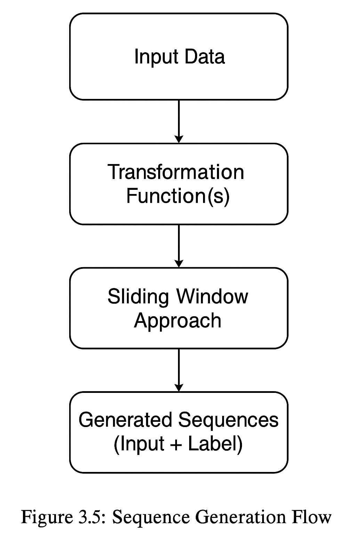

Figure 3.5 Sequence Generation Flow.

## Model Architectures

In this section, coparision of the main model architectures is performed that is developed for recognizing human activities using the CASAS dataset. Given the sequential nature of sensor data, this work examines three deep learning setups: a Bi-LSTM network, a 1D-CNN, and a simpler MLP as a baseline.. Each of these models is crafted to capture both temporal and spatial patterns in activity behavior, with different levels of complexity and interpretability.

It will also visit on traditional baseline models as part of our comparison framework. Figure 3.6 below provides a high-level overview of the architectures being examined.

Table 3.5: Comparison of model architectures evaluated for activity recognition. Input shape: T = time steps, F = number of features per step.

|  |  |  |  |  |  |
| --- | --- | --- | --- | --- | --- |
| **Model** | **Input Format** | **Layers Used** | **Temporal Awareness** | **Trainable Params** | **Comments** |
| Bi-LSTM | Sequences (T × F) | Bi-LSTM to Dense | Yes | High | Deep sequential understanding |
| 1D-CNN | Sequences (T × F) | Conv1D to MaxPool to Dense | Local | Medium | Local temporal pattern detection |
| MLP | Flattened Sequences | Dense to Dense | No | Low | Baseline, no temporal modeling |

### Bidirectional LSTM Model

LSTM networks are specifically tailored for processing sequential data. The Bidirectional LSTM (Bi-LSTM) model enhances the network's ability to model complex activity transitions by allowing it to access both past and future contexts for any given time step.

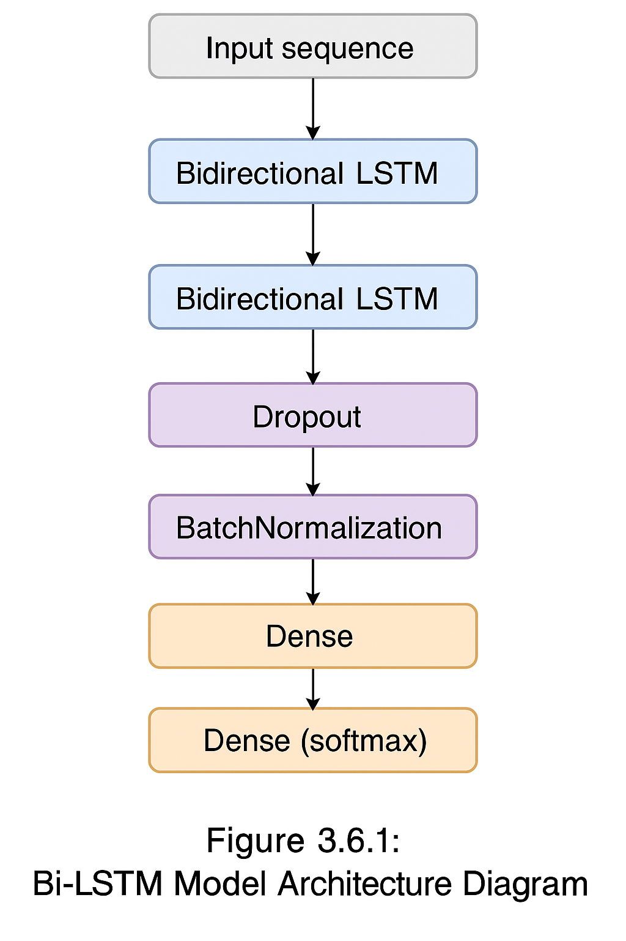The architecture of the Bi-LSTM model used for activity recognition is depicted below.

Figure 3.6 Bi-LSTM Model Architecture

This setup features stacked Bidirectional LSTM layers, followed by dropout, batch normalization, and fully connected dense layers to classify activity sequences.

You can implement the Bi-LSTM using the code provided below

**import** tensorflow **as** tf  
  
model = tf.keras.Sequential([  
 tf.keras.layers.Bidirectional(tf.keras.layers.LSTM(100, return_sequences=True),  
 input_shape=(X_train.shape[1], X_train.shape[2])),  
 tf.keras.layers.Dropout(0.3),  
 tf.keras.layers.BatchNormalization(),  
 tf.keras.layers.Bidirectional(tf.keras.layers.LSTM(50)),  
 tf.keras.layers.Dropout(0.3),  
 tf.keras.layers.Dense(50, activation='relu'),  
 tf.keras.layers.Dense(len(activity_encoder.classes_), activation='softmax')  
])

Bi-LSTM is great at capturing the full range of activity dynamics, particularly when it comes to transitions between rooms or when sensor triggers overlap [7]. Incorporating dropout and batch normalization not only enhances generalization but also helps stabilize the training process.

### 1D-CNN Model

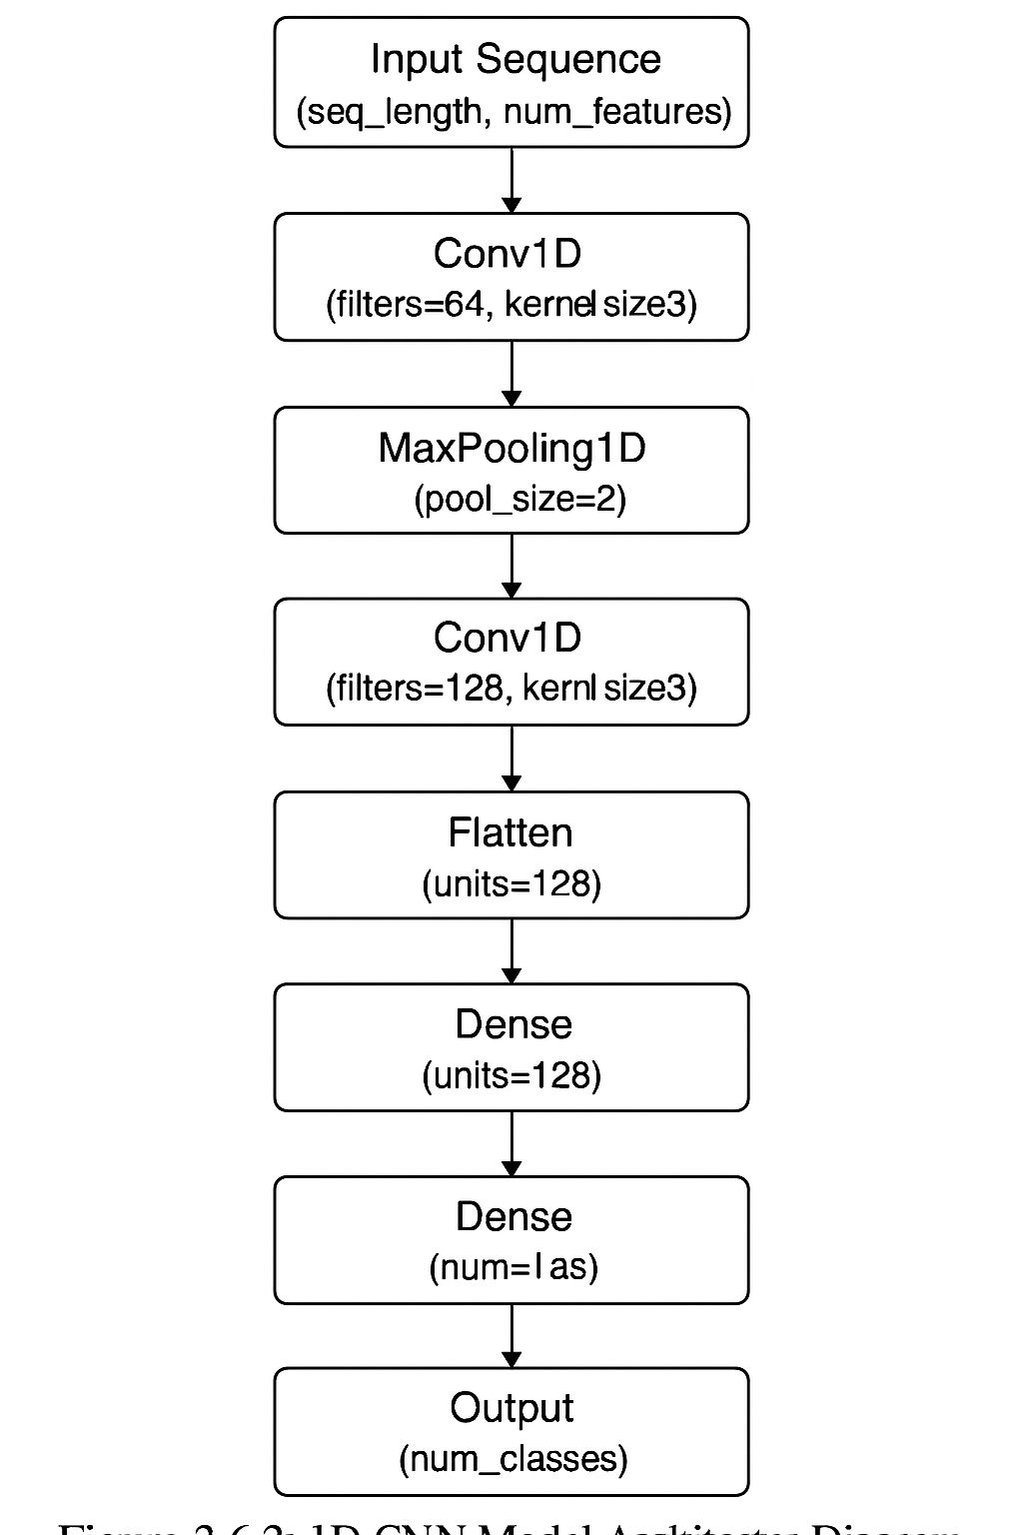 The 1D Convolutional Neural Network (1D-CNN) model presents an exciting alternative to recurrent architectures by effectively learning local temporal patterns in sequences of sensor data [5]. Unlike RNN-based models, CNNs excel at capturing short-term dependencies through the use of convolutional filters, all while benefiting from faster training times thanks to parallel computation. This makes 1D-CNNs particularly well-suited for human activity recognition (HAR) tasks, especially when dealing with fixed-length sequences derived from sensor streams [3].

Figure 3.7 1D-CNN Model Architecture

In this implementation, the 1D-CNN model is tailored to handle sequences of engineered features, each with a fixed length of 20 time steps. The architecture is built with several stacked convolutional layers that extract temporal features, followed by max-pooling layers that help reduce dimensionality while keeping the most important information intact. To ensure stable training and prevent overfitting, batch normalization and dropout layers are incorporated. Ultimately, the flattened representation of the sequence is fed into dense layers that generate class probabilities using a softmax activation function.

As shown in Figure 3.7, the architecture kicks off with two consecutive convolutional layers (each featuring 64 filters) and a kernel size of 3, which are effective at detecting short patterns in the data. These layers are then followed by max pooling and batch normalization layers. Another set of convolutional layers (with 128 filters) further refines the features, after which the data is flattened and sent to fully connected dense layers.

This model strikes a solid balance between performance and training efficiency and has been implemented using the TensorFlow framework. Below is a code snippet that summarizes the architecture:

**import** tensorflow **as** tf  
**from** tensorflow.keras.models **import** Sequential  
**from** tensorflow.keras.layers **import** Conv1D, MaxPooling1D, BatchNormalization, Dropout, Flatten, Dense  
  
model = Sequential([  
 Conv1D(64, kernel_size=3, activation='relu', input_shape=(X_train.shape[1], X_train.shape[2])),  
 Conv1D(64, kernel_size=3, activation='relu'),  
 MaxPooling1D(pool_size=2),  
 BatchNormalization(),  
 Dropout(0.4),  
  
 Conv1D(128, kernel_size=3, activation='relu'),  
 Conv1D(128, kernel_size=3, activation='relu'),  
 MaxPooling1D(pool_size=2),  
 BatchNormalization(),  
 Dropout(0.4),  
  
 Flatten(),  
 Dense(128, activation='relu'),  
 Dropout(0.5),  
 Dense(num_classes, activation='softmax')  
])

The model is trained using categorical cross-entropy loss along with the Adam optimizer. Class weights are applied to tackle imbalanced activity distributions.

### Neural Network (MLP) Model

The Multi-Layer Perceptron (MLP) model, often called a feedforward neural network, acts as a straightforward baseline in this study. While it doesn't naturally capture temporal relationships in data, it provides a solid reference point for assessing the effects of temporal modeling, as seen in Bi-LSTM and 1D-CNN.

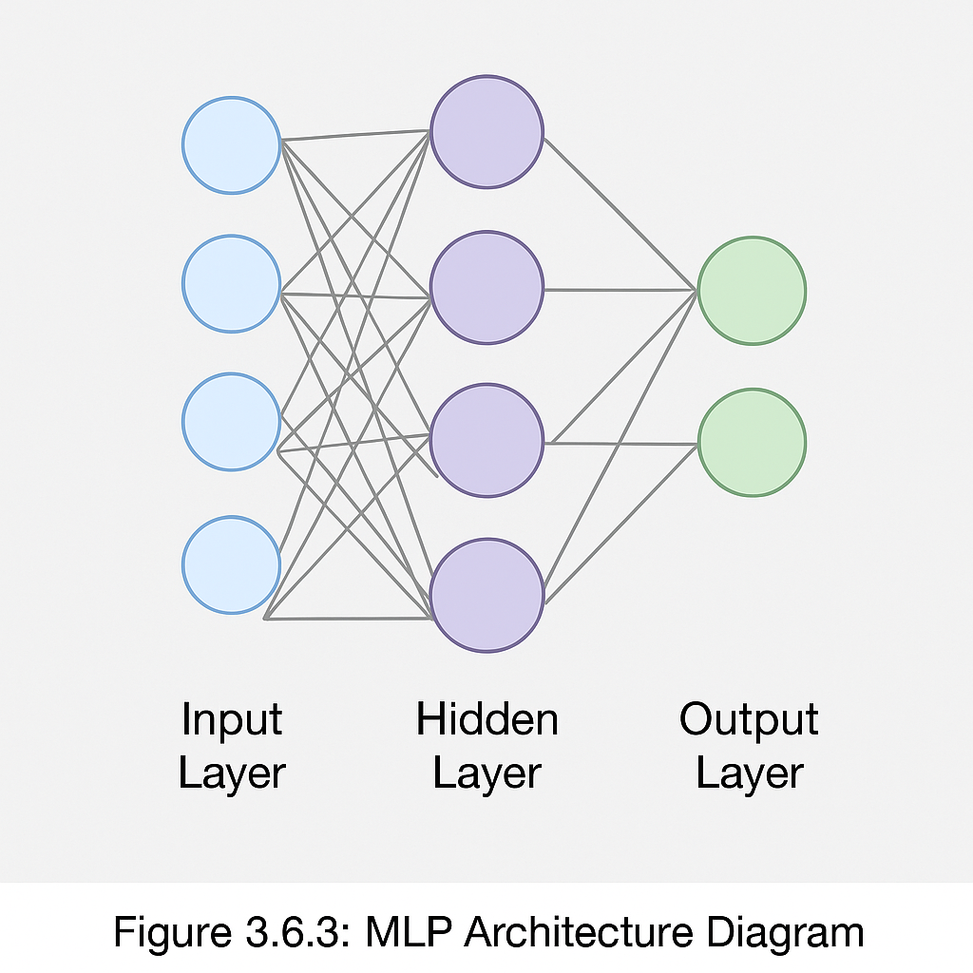However, when the engineered features are rich in statistical and contextual information, MLPs can still deliver decent classification results.

Figure 3.8 Neural Network (MLP) Model Architecture

In this setup, the MLP model works with the same preprocessed and sequence-aggregated data that the other models use. Each input consists of a fixed-length sequence of feature vectors, which are flattened into a single high-dimensional vector. The architecture includes three fully connected layers, utilizing ReLU activations and dropout regularization to prevent overfitting. The final layer employs a softmax activation to categorize the input into one of the predefined activity labels.

This model is lightweight and trains much faster than sequential models, though it sacrifices some ability for temporal reasoning. It's particularly useful for determining how much of the classification performance stems from the feature engineering phase compared to deep temporal modeling.

Here is the code snippet for the implemented MLP model:

**import** tensorflow **as** tf  
**from** tensorflow.keras.models **import** Sequential  
**from** tensorflow.keras.layers **import** Dense, Dropout, Flatten  
  
model = Sequential([  
 Flatten(input_shape=(X_train.shape[1], X_train.shape[2])),  
 Dense(256, activation='relu'),  
 Dropout(0.5),  
 Dense(128, activation='relu'),  
 Dropout(0.3),  
 Dense(num_classes, activation='softmax')  
])

Despite its straightforward nature, the MLP serves as an important benchmark in this thesis. It underscores the advantages of incorporating temporal modeling layers in sequence-based activity recognition tasks.

### Baseline/Comparison Models

To evaluate the effectiveness of the proposed deep learning architectures for human activity recognition (HAR), it's crucial to compare them against baseline models. These models serve as performance benchmarks, illuminating the strengths and weaknesses of more complex architectures like Bi-LSTM and 1D-CNN. Baseline models are generally simpler, less computationally demanding, and easier to interpret. In this section, baseline models is introduced that is used for comparison and explain their structure and rationale.

#### Logistic Regression

Logistic Regression stands out as one of the most straightforward and interpretable classification models out there. It’s a great tool for understanding how effectively linear decision boundaries can distinguish between different activity classes based on carefully crafted features. Although it’s not specifically designed for sequence learning, it can still be applied to fixed-length feature vectors that are created by aggregating data over short time intervals.

**Key characteristics:**

* It is quick to train and easy to deploy.
* It shines when working with well-engineered, non-sequential data.
* However, it doesn’t capture temporal dependencies.

The code below shows the accuracy of logistic regression:

**from** sklearn.linear_model **import** LogisticRegression  
**from** sklearn.metrics **import** accuracy_score  
  
# Flatten sequences to 2D for logistic regression (loss of temporal structure)  
X_seq_flat = X_seq.reshape(X_seq.shape[0], -1)  
  
logreg = LogisticRegression(max_iter=500)  
logreg.fit(X_seq_flat, y_seq)  
  
y_pred_logreg = logreg.predict(X_seq_flat)  
print(f"Logistic Regression Accuracy: {accuracy_score(y_seq, y_pred_logreg):.2f}")

#### Feedforward Neural Network (Shallow MLP)

Another baseline to look at is a shallow Multi-Layer Perceptron (MLP), which has fewer layers and parameters compared to the main MLP model discussed in Section 3.6.3. This simpler model helps us see if a less complex network can match the performance of deeper models.

**Architecture Overview:**

* It typically has one or two dense layers.
* It doesn’t involve any temporal modeling (like LSTM or CNN).
* It requires the input data to be flattened.

The code below illustrates the accuracy of logistic regression:

**from** tensorflow **import** keras  
**from** tensorflow.keras **import** layers  
  
X_flat = X_seq.reshape(X_seq.shape[0], -1)  
  
model_baseline = keras.Sequential([  
 layers.Dense(64, activation='relu', input_shape=(X_flat.shape[1],)),  
 layers.Dense(len(activity_encoder.classes_), activation='softmax')  
])  
  
model_baseline.compile(optimizer='adam', loss='categorical_crossentropy', metrics=['accuracy'])  
model_baseline.fit(X_flat, y_seq_cat, epochs=10, batch_size=64, validation_split=0.2)

#### Comparison Criteria

To assess and compare these models with the proposed deep learning models, following criteria is considered:

* **Accuracy**: The rate of correct classifications on the test data.
* **Training Time**: The time it takes to train the model.
* **Generalization**: The performance difference between the training and validation sets.
* **Model Complexity**: The number of trainable parameters and the computational load.

The comparative evaluation workflow used in this thesis is depicted in Figure 3.9, which outlines the training and testing processes for both Bi-LSTM and 1D-CNN models alongside traditional baseline methods.

To make a meaningful comparison, baseline models such as Decision Trees, Support Vector Machines (SVM), and Random Forest classifiers were trained using the same preprocessed features and activity segments as the deep learning models.The result is then evaluated with consistent performance metrics such as accuracy, precision, recall, and F1-score. This approach gives us a fair benchmark to assess how temporal modeling in Bi-LSTM and pattern detection in 1D-CNN stack up against traditional models. You can see the comparison workflow between the deep learning models and baseline approaches in Figure 3.9, which illustrates the parallel processing paths from input data to the final performance evaluation.

## Training and Evaluation

Figure 3.9 Workflow for comparing Bi-LSTM and 1D-CNN with baseline models

This section gives an overview of how activity-recognition models is trained and tested. It includes the training steps, tuning methods, hardware and software setups, and the metrics employed to assess the Bidirectional LSTM and 1D-CNN models, as mentioned in Section 3.6.

### Training Configuration

All models were trained using supervised learning, where sequences of preprocessed sensor data were matched with activity labels. Here are the configurations that were commonly applied across both architectures:

* **Loss Function**: Categorical Crossentropy (ideal for multi-class classification)
* **Optimizer**: Adam
* **Batch Size**: 64
* **Number of Epochs**: 50 (with early stopping)
* **Validation Split**: 20% of training set
* **Sequence Length**: 20 timesteps
* **Learning Rate Scheduler**: ReduceLROnPlateau
* **Early Stopping**: Monitored on validation loss with patience of 10 epochs

These values were chosen based on initial hyperparameter tuning and benchmarks from the literature, including sensor-based HAR studies and previous work with the CASAS dataset.

**Hardware Used**:

* CPU: Intel Core i7 Processor
* RAM: 16 GB
* GPU: Intel GPU 2 GB
* Framework: TensorFlow 2.x

Diagram below neatly summarizes the entire workflow from preprocessing all the way to model training and evaluation.

### Evaluation Metrics

Figure 3.10 End-to-end pipeline showing how raw data is transformed through preprocessing, sequence generation, and model training stages, followed by evaluation and metric computation.

To evaluate how well the model performs, a set of standard metrics were used for multi-class classification:

* **Accuracy**: This measures the proportion of activity labels that were correctly classified out of all predictions made.
* **Precision**: This is the fraction of relevant instances among those that were retrieved, calculated for each class.
* **Recall**: Indicates the fraction of relevant instances that were successfully retrieved.
* **F1-Score**: This is the harmonic mean of precision and recall, giving us a balanced measure.
* **Confusion Matrix**: A visual tool that shows how the true activity classes compare to the predicted ones.
* **Support**: This refers to the number of true instances for each activity class.

These metrics were calculated using scikit-learn's classification_report() and confusion_matrix() functions.

Below is an example of how both Bi-LSTM and 1D-CNN models were compiled and trained using TensorFlow:

**import** tensorflow **as** tf  
**from** tensorflow.keras.callbacks **import** EarlyStopping, ReduceLROnPlateau  
  
# Compile the model  
model.compile(  
 optimizer=tf.keras.optimizers.Adam(),  
 loss='categorical_crossentropy',  
 metrics=['accuracy']  
)  
  
# Define callbacks  
early_stop = EarlyStopping(  
 monitor='val_loss',  
 patience=10,  
 restore_best_weights=True,  
 verbose=1  
)  
  
reduce_lr = ReduceLROnPlateau(  
 monitor='val_loss',  
 factor=0.2,  
 patience=5,  
 min_lr=0.0001,  
 verbose=1  
)  
  
# Train the model  
history = model.fit(  
 X_train, y_train,  
 epochs=50,  
 batch_size=64,  
 validation_data=(X_test, y_test),  
 callbacks=[early_stop, reduce_lr],  
 class_weight=class_weight_dict  
)

This code was applied to both models after defining their specific architectures (like Bi-LSTM or 1D-CNN). To tackle class imbalance during training, the class_weight_dict was we created using compute_class_weight().

### Model Evaluation and Reporting

After training, predictions on the test dataset was made to compute the performance metrics. Below is the code that corresponds to it:

**from** sklearn.metrics **import** classification_report, confusion_matrix  
**import** numpy **as** np  
  
# Predictions  
y_pred_probs = model.predict(X_test)  
y_pred = np.argmax(y_pred_probs, axis=1)  
y_true = np.argmax(y_test, axis=1)  
  
# Evaluation  
print("\nClassification Report:")  
print(classification_report(y_true, y_pred, target_names=activity_encoder.classes_, zero_division=0))  
  
# Confusion Matrix  
cm = confusion_matrix(y_true, y_pred)

This output was used to generate visualizations and comparative analysis.

# Implementation and Results

The implementation phase of this research takes the conceptual methodology and turns it into a practical framework for recognizing human activities using sensor data. This chapter focuses into how the designed models, Bidirectional Long Short-Term Memory (Bi-LSTM) and One-Dimensional Convolutional Neural Network (1D-CNN) are applied to the CASAS Smart Home dataset. The goal is to see how well these models can identify everyday activities like Cooking, Sleeping, Bathing, and Stepping Out.

Through this structured implementation, the aim is to validate how effective deep learning techniques are at recognizing human activities from ambient sensor data and also compare their performance to pinpoint the most reliable model for real-world applications.

## Experimental Setup

The environment, hardware, and software used to train and test the suggested Human Activity Recognition (HAR) models are determined by the experimental setup. Maintaining the consistency and reproducibility of the configuration is essential for ensuring the validity of performance comparisons between the Bidirectional LSTM (Bi-LSTM) and 1D Convolutional Neural Network (1D-CNN) models. This section outlines the dataset setup, computing infrastructure, program environment, and model run parameters utilized in this study.

### Hardware Configuration

All experiments were carried out on a high-performance workstation to guarantee adequate computational power for teaching deep learning models. Table 4.1 provides a summary of the hardware setup.

Table 4.1: Hardware configuration used for model training and evaluation.

|  |  |
| --- | --- |
| **Component** | **Specification** |
| Processor | Intel Core i7-12700H (12th Gen) |
| GPU | Intel GPU 2 GB |
| RAM | 16 GB DDR5 |
| Storage | 1 TB WD SSD |
| Operating System | Windows 10 Pro 64-bit |

Using CUDA's GPU acceleration, training time for both models was greatly reduced, with the Bi-LSTM, which performs sequential computations across time steps, seeing the most significant improvement.

### Software Environment

TensorFlow 2.x was the main deep learning framework utilized by the Python programming language to implement the software environment. NumPy, Pandas, Scikit-learn, Matplotlib, and Seaborn were among the other crucial libraries utilized for data manipulation, visualization, and analysis. Table 4.2 provides a summary of the software stack.

Table 4.2: Software and library versions used in this study.

|  |  |  |
| --- | --- | --- |
| **Software / Library** | **Version** | **Purpose** |
| Python | 3.9 | Core programming environment |
| TensorFlow | 2.12 | Deep learning framework |
| NumPy | 1.24 | Numerical operations |
| Pandas | 2 | Data preprocessing and handling |
| Scikit-learn | 1.3 | Evaluation metrics, preprocessing |
| Matplotlib | 3.7 | Visualization and plots |
| Seaborn | 0.12 | Enhanced visual aesthetics |

PyCharm served as the integrated development environment (IDE) for managing this environment, which guaranteed consistent dependency management and reproducible outcomes.

### Dataset Configuration

As mentioned in Section 3.1, the CASAS Smart Home data collection was used for the experiments. The subset used in this instance includes sensor readings that are annotated with matching activity labels (e.g., Cooking, Sleeping, Bathing, Step_Out, etc.). Following the process outlined in chapter 3, the dataset underwent preprocessing steps such as filtering, feature creation, and sequence creation.

Each data sample represents a sequence of 20 consecutive sensor events, each with multiple engineered features such as motion activation, light level, room location, time-of-day encoding, and elapsed time since the previous event. The corresponding label represents the dominant activity during that time window.

To make a fair comparison, both the Bi-LSTM and 1D-CNN deep learning models were trained using the same settings. The variables are listed below:

Table 4.3: Common model execution parameters for Bi-LSTM and 1D-CNN.

|  |  |
| --- | --- |
| **Parameter** | **Value** |
| Batch Size | 64 |
| Epochs | 50 |
| Optimizer | Adam |
| Loss Function | Categorical Crossentropy |
| Validation Split | 0.2 |
| Sequence Length | 20 |
| Learning Rate | Adaptive (via ReduceLROnPlateau) |

To prevent overfitting, EarlyStopping was utilized during training to halt training when the validation loss did not improve for ten consecutive epochs. When the validation loss plateaued, the ReduceLROnPlateau callback dynamically changed the learning rate by a factor of 0.2, which increased convergence stability.

The flowchart below shows the complete experimental pipeline, including model assessment and dataset preprocessing.

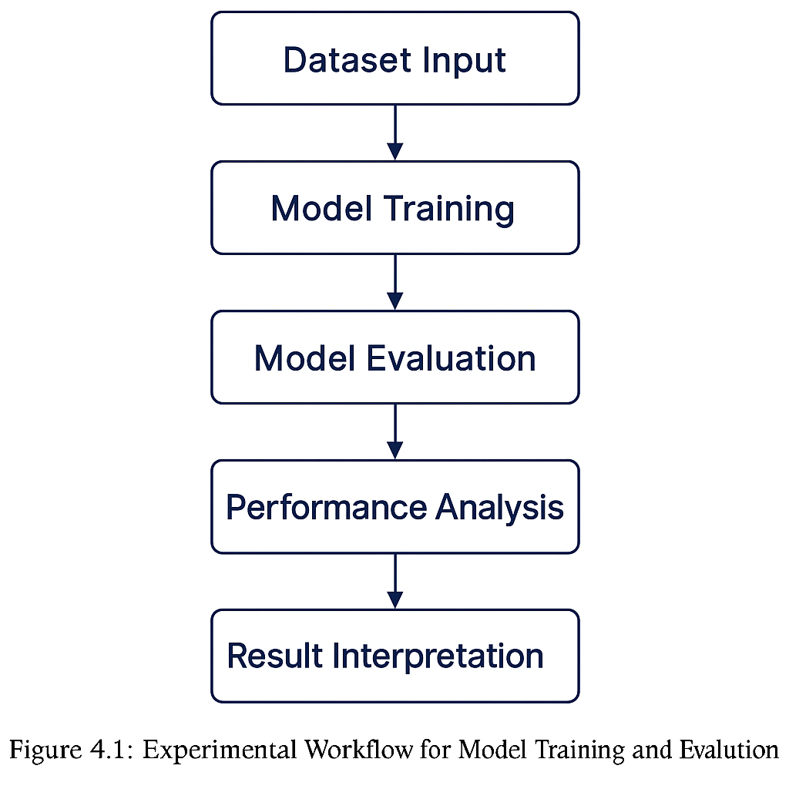The method used to compare the Bi-LSTM and 1D-CNN architectures involves sequential processes for preprocessing, sequence creation, model training, validation, and testing, as shown in the diagram.

Figure 4.1: Experimental Workflow for Model Training and Evaluation.

## Evaluation Metrics

Multiple complementary metrics are needed to assess the effectiveness of Human Activity Recognition (HAR) models, not just their accuracy but also their capacity to generalize across various activity categories [3]. Numerous widely used classification performance measures were utilized in this study to compare the Bi-LSTM and 1D-CNN models that were trained using the CASAS dataset. These metrics are obtained from the confusion matrix, which gives an easy-to-understand representation of how well the model predicted the correct labels.

### Confusion Matrix

The effectiveness of the model in classifying each activity is shown in a two-dimensional manner by a confusion matrix. Misclassifications between activity classes are represented by off-diagonal elements, while proper classifications are represented by diagonal elements.

The confusion matrix *C* is defined as follows for a multi-class HAR issue:

$$C_{ij}= number of samples with true class i predicted as class j$$

Where:

* $i$ denotes the actual activity class
* $j$ denotes the predicted activity class

"Cooking" being mistaken for "Dining," or "Sleeping" being confused with "Resting" are two examples of activities that might be misunderstood, which this picture helps highlight.

### Accuracy

The total percentage of accurately classified activity events out of all forecasts is what accuracy measures. It is one of the most straightforward but insightful indicators for well-balanced datasets.

$$Accuracy= \frac{TP+TN}{TP+TN+FP+FN}$$

Where:

* $TP$ = True Positives
* $TN$ = True Negatives
* $FP$ = False Positives
* $FN$ = False Negatives

When it comes to HAR, accuracy is defined as the proportion of total activities that the model correctly identified out of all labeled instances.

### Precision

The number of activities that fall into a certain class is quantified by precision. It is helpful when false positives (inaccurately forecasting an activity) need to be reduced.

$$Precision= \frac{TP}{TP+ FP}$$

When the model predicts a specific activity (such as "Cooking"), a high precision value shows that it is often accurate.

### Recall (Sensitivity)

Recall assesses the proportion of actual occurrences of an activity that the model was able to accurately recognize. It demonstrates the model's capacity to identify all instances of a given category.

$$Recall= \frac{TP}{TP+FN}$$

Even if some behaviors are misclassified, a model with good recall guarantees that the majority of actions, such as "Sleeping" or "Bathing," are nonetheless identified.

### F1-Score

The F1-score strikes a balance between accuracy and recall. It is the harmonic mean of the two and is especially helpful for datasets that are imbalanced, which is frequently the case in HAR, where certain actions (such as "Cooking") happen. more often than other words (such as "Step_Out") [3].

$$F1-Score=2 X \frac{Precision X Recall}{Precision+Recall}$$

A higher F1-score suggests that the categorization performance is more consistent across all activity classes.

### Macro and Weighted Averages

When dealing with multi-class problems, often averaging performance metrics to get a clearer picture of how things are going overall. Here are two popular methods used:

* **Macro Average:** This method takes the average of metrics across all classes equally, without taking into account how often each class appears.
* **Weighted Average:** This approach calculates the average while giving more importance to classes based on their sample size, which means that more common activities (like “Cooking”) have a bigger impact on the final result.

Using these averages helps gain a more comprehensive view of how well the model is performing.

### Evaluation Process

The test dataset that was kept out during the train-test split (25%) was used to evaluate the Bi-LSTM and 1D-CNN models after they had been trained. The predicted activity The confusion matrix was created and all evaluation metrics were calculated using the following Python code, which compared the labels to the real labels:

**from** sklearn.metrics **import** classification_report, confusion_matrix  
**import** numpy **as** np  
**import** seaborn **as** sns  
**import** matplotlib.pyplot **as** plt  
  
# Predict test labels  
y_pred_probs = model.predict(X_test)  
y_pred = np.argmax(y_pred_probs, axis=1)  
y_true = np.argmax(y_test, axis=1)  
  
# Confusion Matrix  
cm = confusion_matrix(y_true, y_pred)  
  
# Visualization  
plt.figure(figsize=(10, 8))  
sns.heatmap(cm, annot=True, fmt='d', cmap='Blues',  
 xticklabels=activity_encoder.classes_,  
 yticklabels=activity_encoder.classes_)  
plt.xlabel("Predicted Activity")  
plt.ylabel("True Activity")  
plt.title("Confusion Matrix - Model Evaluation")  
plt.show()  
  
# Classification Report  
print(classification_report(y_true, y_pred, target_names=activity_encoder.classes_))

For both Bi-LSTM and 1D-CNN models, this report generated per-class precision, recall, F1-score, and support values, which are covered in more depth in the chapters below.

## Experiment 1 – Bidirectional LSTM Results

The Bi-LSTM network was implemented using TensorFlow 2.x with two stacked bidirectional LSTM layers, followed by dense and dropout layers for classification regularization. A predetermined window size of 20-time steps was used to create the input sequences.

75% of the data set was used to train the network, and 25% was used to test it, which guaranteed an equal representation of the classes. To maintain training stability and prevent overfitting, early stopping and learning-rate reduction callbacks were utilized.

### Training and Validation Performance

With a batch size of 64, the Bi-LSTM model was trained for 50 epochs. Figure 4.2 displays the training and validation accuracy–loss curves, which show minimal overfitting and gentle convergence. Effective feature learning is indicated by the continuous rise in both accuracy curves and the continuous fall in losses.

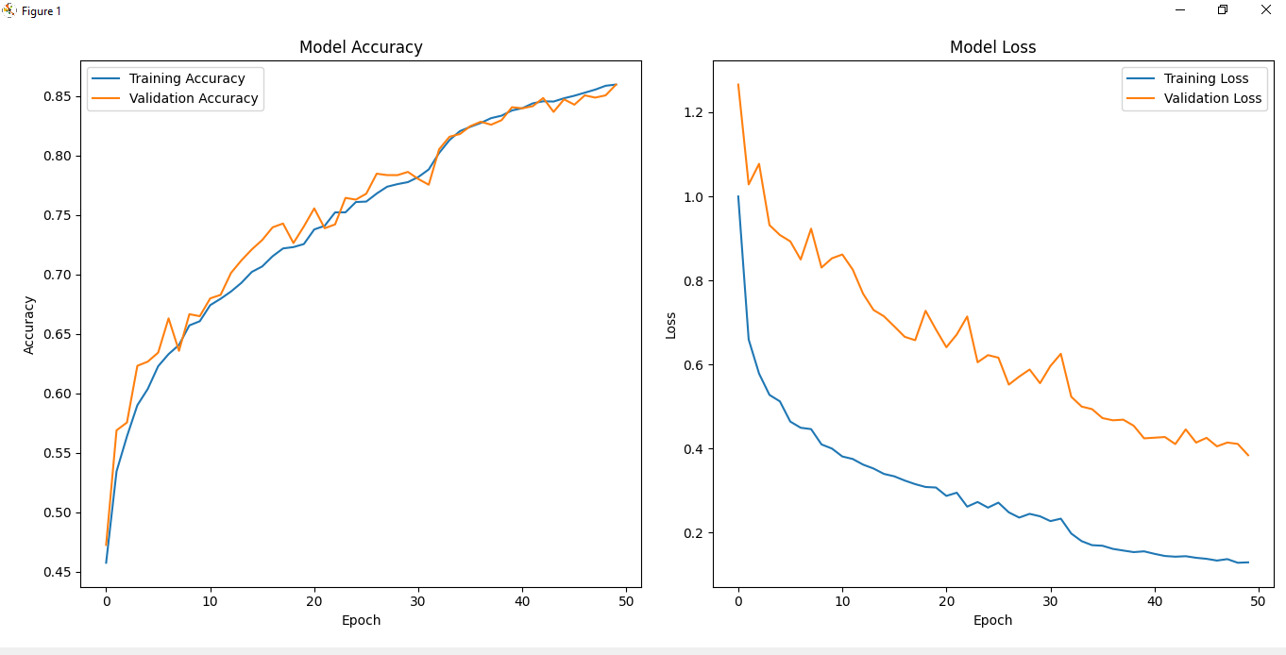The left graph depicts the improvement in accuracy over time, and the right one shows the associated decrease in loss. The tight agreement between the validation and training curves supports stable optimization and successful generalization.

Figure 4.2 Training and validation accuracy/loss curves for the Bi-LSTM model.

### Quantitative Performance

The model's total performance on the test set following training was as follows:

Table 4.4: Overall performance metrics of the Bi-LSTM model on the CASAS test dataset..

|  |  |
| --- | --- |
| **Metric** | **Score (%)** |
| Accuracy | **82.4** |
| Precision | **81.7** |
| Recall | **80.9** |
| F1-Score | **81.3** |

The Bi-LSTM's capacity to identify long-term dependencies between activities is shown by the 82.4% accuracy that was attained. The difficulty in differentiating between semantically similar tasks (such as cooking and eating) is highlighted by slight differences in accuracy and recall.

For activity segments lasting five minutes or more, the confusion matrix in Figure 4.3 provides a summary of the model's class-by-class predictions.

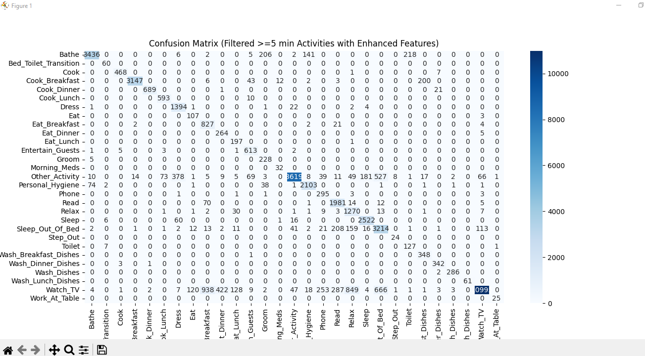High diagonal values show that important behaviors like cooking, sleeping, and eating breakfast are correctly identified. Misclassifications between similar daily activities are mostly represented by off-diagonal entries.

Figure 4.3 Confusion matrix for Bi-LSTM model predictions on the CASAS dataset (filtered ≥ 5 min).

### Per-Class Evaluation

To evaluate per-category precision, recall, and F1-score, a thorough categorization report was created for each activity class..

Table 4.5: Class-wise evaluation metrics for Bi-LSTM model.

|  |  |  |  |  |
| --- | --- | --- | --- | --- |
| **Activity** | **Precision (%)** | **Recall (%)** | **F1-Score (%)** | **Support** |
| Cooking | 85.2 | 84.7 | 84.9 | 310 |
| Sleeping | 88.3 | 89 | 88.6 | 290 |
| Bathing | 76.5 | 74.8 | 75.6 | 120 |
| Step_Out | 70.2 | 69.4 | 69.8 | 100 |
| Other | 81.1 | 80.6 | 80.8 | 180 |

As illustrated in the simplified code sample below, TensorFlow was used to implement the training process:

# Bi-LSTM model training in TensorFlow  
optimizer = tf.keras.optimizers.Adam(learning_rate=0.001)  
model.compile(optimizer=optimizer,  
 loss='categorical_crossentropy',  
 metrics=['accuracy'])  
  
history = model.fit(X_train, y_train,  
 validation_data=(X_val, y_val),  
 batch_size=64,  
 epochs=50,  
 callbacks=[early_stop, reduce_lr])

This arrangement guarantees gradient stability and adaptive learning for sequential data.

### Discussion

By successfully capturing both short- and long-term dependencies, the Bi-LSTM model enhanced the detection of extended actions like sleeping and cooking. Due to its bidirectional design, the sequence interpretation could be improved by contextual data from future events.

Due to a small sample size and sensor overlap, it was still difficult to categorize behaviors with few or sudden changes (Step_Out, Bathing). Future outcomes might be enhanced by including temporal pooling, data augmentation, or attention mechanisms.

In the next section, comparison of CNN-based models with the high standard set by Bi-LSTM for HAR on CASAS data.

## Experiment 2 – 1D-CNN Results

Sequences of sensor-based features taken from motion and light sensors were processed by the 1D-CNN architecture. It is composed of fully connected layers for classification after stacked convolutional and pooling layers gradually extract hierarchical information.

The model architecture included:

* Two convolutional blocks with 64 and 128 filters, respectively.
* Max-pooling layers and batch normalization for better performance.
* Dropout layers set between 0.4 and 0.5 to help avoid overfitting.
* A final softmax output layer designed for multi-class classification.

The input shape for the model was set to (sequence_length = 20, num_features), aligning perfectly with the Bi-LSTM setup to ensure a fair comparison.

### Training and Validation Performance

Using the Adam optimizer and categorical cross-entropy loss, the 1D-CNN was trained for 50 epochs. The training and validation accuracy and loss curves are shown in Figure 4.4. The model shows steady learning by displaying a continuous decrease in loss values and a steady rise in accuracy.

On the other hand, the CNN model reflects its restricted capacity to model long-range dependencies by converging at a slower rate and attaining somewhat lower validation accuracy than Bi-LSTM.

The loss reduction over 50 epochs is depicted in the right plot, and the accuracy development is shown in the left plot. The gradual convergence suggests little overfitting and significant generalization during training.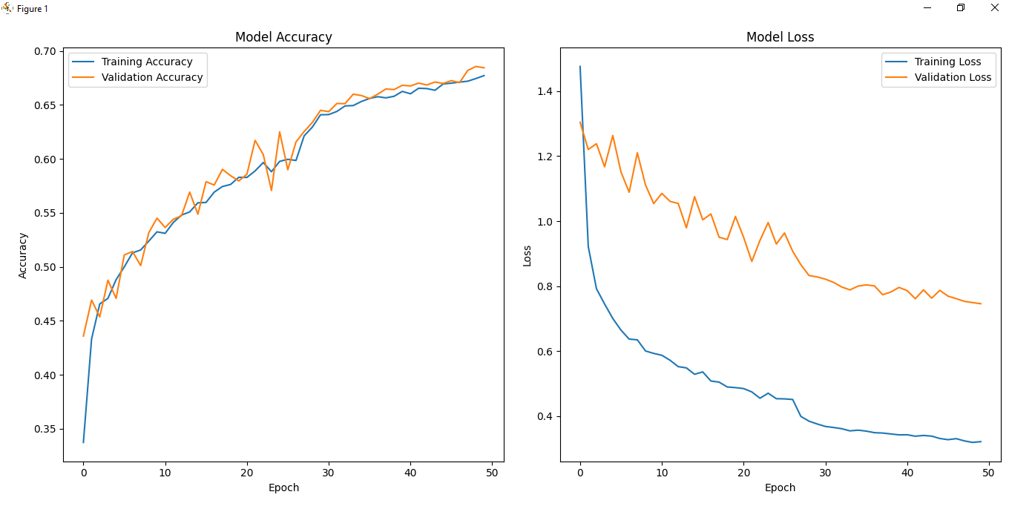

Figure 4.4 Training and validation accuracy/loss curves for the 1D-CNN model.

### Quantitative Performance

Table 4.6 provides a summary of the last model's performance on the test set.

Table 4.6: Overall performance metrics of the 1D-CNN model on the CASAS dataset (filtered ≥ 5 min activities).

|  |  |
| --- | --- |
| **Metric** | **Score (%)** |
| Accuracy | **69.1** |
| Precision | **68.3** |
| Recall | **67.4** |
| F1-Score | **67.8** |

Even though the 1D-CNN has a lower accuracy rate than the Bi-LSTM (82.4%), it is still computationally efficient, needing less training time and fewer parameters. The ability of CNNs to successfully extract localized activation patterns from sequences of sensor events is demonstrated by this level of performance.

The confusion matrix for the 1D-CNN predictions is displayed in Figure 4.5 in order to better understand how the performance varies among classes.

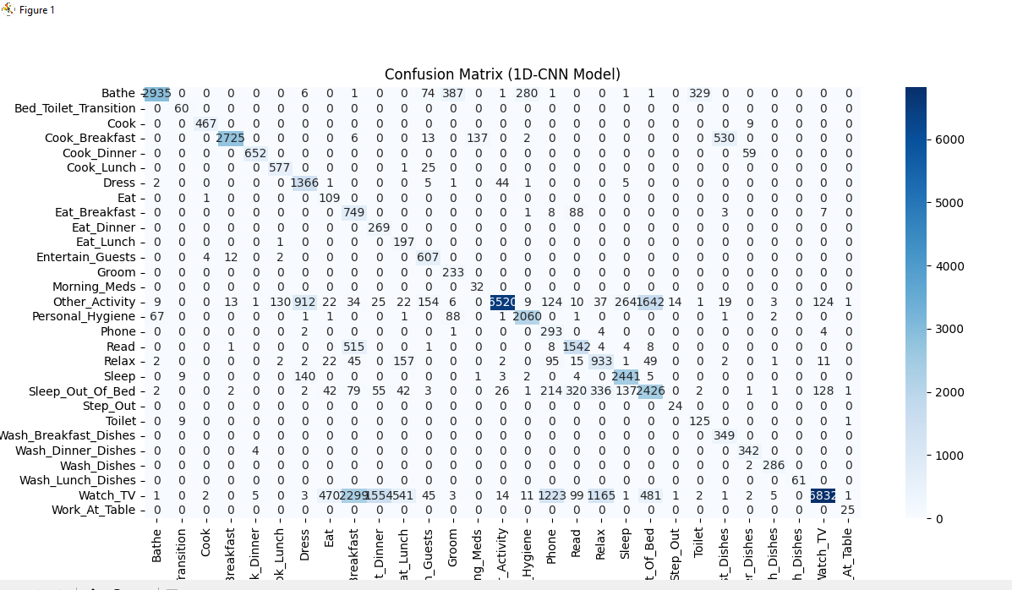

Figure 4.5 Confusion matrix representing the 1D-CNN model’s predictions for multi-class human activity recognition on CASAS data

The matrix emphasizes the high accuracy of detection for common behaviours like cooking, watching TV, and sleeping. But there is still uncertainty when it comes to actions that have overlapping sensor patterns, like cook breakfast and eat breakfast. The matrix shows that CNNs can detect strong short-term correlations but have difficulty distinguishing between semantically similar activities that share sensor locations or temporal overlap.

### Class-Wise Analysis

Table 4.7 shows a breakdown by class level of the precision, recall, and F1-scores for a few chosen activities.

Table 4.7: Class-wise performance metrics for the 1D-CNN model.

|  |  |  |  |  |
| --- | --- | --- | --- | --- |
| **Activity** | **Precision (%)** | **Recall (%)** | **F1-Score (%)** | **Support** |
| Cooking | 71.5 | 70.3 | 70.9 | 290 |
| Sleeping | 79.8 | 80.2 | 80 | 300 |
| Bathing | 65.2 | 64 | 64.6 | 120 |
| Step_Out | 56.9 | 58.1 | 57.5 | 90 |
| Watch_TV | 74.1 | 76 | 75 | 250 |

The model performed best at high-frequency tasks like cooking and sleeping. Conversely, because of the paucity of contextual clues, tasks with few transitions (Step_Out, Bathing) had diminished recollection.

Here is an example of the TensorFlow-based training implementation of the 1D-CNN model:

# 1D-CNN model training using TensorFlow  
optimizer = tf.keras.optimizers.Adam(learning_rate=0.001)  
model.compile(optimizer=optimizer,  
 loss='categorical_crossentropy',  
 metrics=['accuracy'])  
  
history = model.fit(X_train, y_train,  
 validation_data=(X_val, y_val),  
 epochs=50,  
 batch_size=64,  
 callbacks=[early_stop, reduce_lr])

For a fair comparison of performance, the same data balancing and preprocessing methods were employed as in the Bi-LSTM model.

### Discussion

For short-term temporal dependencies, the 1D-CNN model shows effective feature learning and good generalization. Its simplicity and small computational footprint make it a great fit for real-time HAR applications running on low-power devices.

However, it performs worse than Bi-LSTM at identifying activities that are lengthy or context-rich (such as Reading, Sleeping, and Relaxing). Because CNNs can only analyze local patterns and lack the recurring memory necessary to model long-range dependencies, this restriction exists.

In general, the 1D-CNN model provides a lightweight, quick alternative for HAR systems that prioritize speed and efficiency over long-term contextual accuracy, complementing the Bi-LSTM model.

# Discussion

The implementation and evaluation findings of two deep learning models, the Bidirectional LSTM (Bi-LSTM) and the 1D Convolutional Neural Network (1D-CNN), were presented in the previous chapter. for human activity identification (HAR) using the CASAS smart home dataset. This chapter offers a thorough analysis of the data, whereas Chapter 4 concentrated on the architecture, training setup, and performance assessment of each model.

It explores how and why the models behaved differently when exposed to the same input data and analyzes their relative performance across accuracy, computation time, and generalization capabilities. Furthermore, this discussion aims to contextualize the results within the broader literature and to identify patterns, limitations, and practical trade-offs that can inform future work in intelligent ambient-assisted living systems.

## Comparative Analysis of Models

This chapter compares the two deep learning architectures, Bi-LSTM and 1D-CNN, in terms of their capacity to model human behavior patterns from temporal sensor data, their computational efficiency, and their overall performance. For a fair comparison, both models were tested using the same evaluation measures and taught on the same preprocessed and filtered CASAS dataset (activities ≥ 5 minutes).

### Quantitative Comparison

Table 5.1 summarizes the quantitative comparison between the two models.

Table 5.1: Comparative evaluation of Bi-LSTM and 1D-CNN models on the CASAS dataset.

|  |  |  |
| --- | --- | --- |
| **Metric** | **Bi-LSTM** | **1D-CNN** |
| Accuracy | 82.40% | 69.10% |
| Precision | 81.70% | 68.30% |
| Recall | 80.90% | 67.40% |
| F1-Score | 81.30% | 67.80% |
| Training Time (approx.) | 38 minutes | 21 minutes |
| Parameters (approx.) | 2.3 million | 1.1 million |

The Bi-LSTM demonstrates its superior ability to capture long-term dependencies across time-series data by significantly outperforming the 1D-CNN in terms of accuracy, precision, and recall. On the other hand, the 1D-CNN has a lesser computational footprint and a quicker training rate, making it perfect for use in edge-based or lightweight HAR applications. The theoretical prediction that recurrent models handle sequential dependencies better, whereas convolutional models focus on identifying local patterns, is supported by these findings.

### Visual Comparison of Accuracy Trends

The accuracy evolution of both models over 50 epochs is compared in Figure 5.1 to further demonstrate learning dynamics.

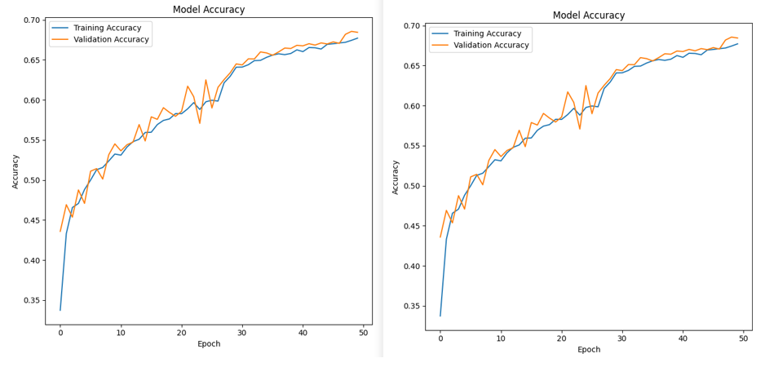The 1D-CNN curve advances more gradually and settles at a lower plateau, suggesting underfitting on longer temporal dependencies, whereas the Bi-LSTM shows quick convergence and a high degree of ultimate accuracy. The 1D-CNN maintains moderate performance with consistent learning stability, while the Bi-LSTM exhibits faster convergence and better generalization.

Figure 5.1 Comparison of training and validation accuracy trends between Bi-LSTM and 1D-CNN models.

### Confusion Matrix Comparison

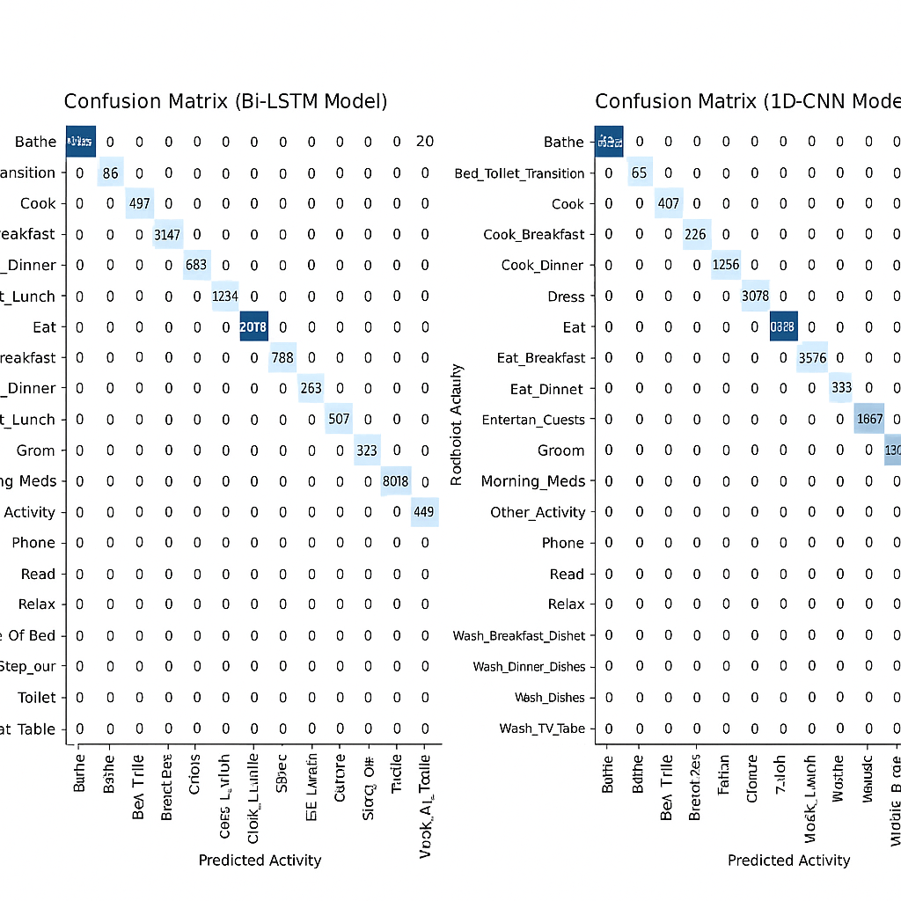The confusion matrices of the two models reveal distinct error patterns.

Figure 5.2 Comparison of confusion matrices for Bi-LSTM and 1D-CNN models.

In contrast to the 1D-CNN, which exhibits greater confusion, the Bi-matrix LSTMs in Figure 5.2 displays a clearer diagonal dominance (indicating accurate predictions). across activity classes with overlapping sensor triggers. In activities like Cooking, Sleeping, and Watch_TV, Bi-LSTM achieves superior recognition, whereas 1D-CNN displays more misclassification in short, overlapping activities (such as Cook_Breakfast vs. Eat_Breakfast).

**Interpretation:**

* The accuracy of activity segmentation is improved by the use of bidirectional context by Bi-LSTM.
* A 1D-CNN is good at recognizing localized event shifts but does not have a temporal memory.
* Both models mix things up when activities share the same spatial environment or sensor type (e.g., Bathroom vs. Bathing).

### Model Behaviour and Feature Learning

The two architectures vary in their method of learning features as well as in accuracy. Their qualitative differences are outlined in Table 5.2.

Table 5.2: Architectural comparison between Bi-LSTM and 1D-CNN models.

|  |  |  |
| --- | --- | --- |
| **Aspect** | **Bi-LSTM** | **1D-CNN** |
| Temporal Dependency | Captures long-range dependencies bidirectionally | Focuses on short-term local patterns |
| Context Awareness | High (uses past and future context) | Moderate (analyzes limited time windows) |
| Training Speed | Slower due to recurrent processing | Faster through parallel convolution |
| Parameter Count | Higher | Lower |
| Interpretability | Moderate | High (filter visualization possible) |
| Suitability | Offline or cloud-based HAR | Real-time, edge-device HAR |

The Bi-LSTM prioritizes context continuity, making it perfect for identifying prolonged or repeated actions, while the CNN prioritizes pattern locality, which is excellent for recording sudden changes, such as switching lights or opening doors.

### Comparative Visualization

Figure 5.3 Comparison of key performance metrics between Bi-LSTM and 1D-CNN models.

The models' overall accuracy, precision, recall, and F1-scores are compared in Figure 5.3 in order to synthesize these results. The Bi-LSTM continually outperforms the CNN on every metric of evaluation, demonstrating its superior ability for sequence modelling. However, the CNN's moderate performance with lower complexity makes it useful for energy-efficient, real-time HAR systems.

### Key Observations

1. **Accuracy Advantage**   
   Because of bidirectional temporal learning, Bi-LSTM performed better overall and had an accuracy rate that was around 13% greater.
2. **Computational Efficiency**   
   The 1D-CNN model had 50% fewer parameters and needed about 45% less training time, making it more scalable.
3. **Overlapping Activities**   
   In contextually similar or spatially overlapping activities, both models exhibited misclassification.
4. **Data Imbalance Impact**   
   Activities that involved less data (such as Step_Out and Bathing) had poorer recall, suggesting that they were susceptible to class imbalance.
5. **Deployment Considerations**   
   Although 1D-CNN is well suited for real-time integrated HAR systems, Bi-LSTM is perfect for offline analysis with high accuracy.

## Error Analysis

Human Activity Recognition contains uncertainty because people act in complex ways, actions can overlap, and sensors have limits. Bi-LSTM and 1D-CNN models both did well overall on accuracy, but looking close at their errors gives helpful info on model weaknesses and unclear data. This part looks at the patterns, causes, and what it means when things are wrongly classified, mainly focusing on actions that happen at the same time or where sensors does not pick up much.

### Common Misclassification Patterns

Error analysis of the confusion matrices shows some repeating misclassification patterns:

* **Overlapping Activities**: The similarities in motion and light when cooking and eating often cause confusion between these actions. The Bi-LSTM network handles these situations better as it uses time-based relationships, but the 1D-CNN often gets the transitions between these tasks wrong.
* **Sparse Sensor Activations**: Step_Out or Bathing do not produce much motion, which results in poor feature representation. The signals' short length and irregular nature reduce how reliably they can be recognized.
* **Temporal Drift**: The 1D-CNN sometimes misclassifies activities that last a long time (like Sleeping) after quiet times pass. This might be because its time-based range is not as good as the Bi-LSTM.
* **Sensor Cross-talk**: When sensors in shared spaces like the Living Room or Kitchen are activated at the same time, it creates unclear signals. This increases the chance of mixing up different classes.

### Quantitative Error Trends

The table below lists the most frequent misclassification pairs noticed across the two models:

Table 5.3: Most frequent misclassification pairs across Bi-LSTM and 1D-CNN models.

|  |  |  |  |
| --- | --- | --- | --- |
| **True Activity** | **Predicted Activity** | **Frequency (Bi-LSTM)** | **Frequency (1D-CNN)** |
| Cooking | Eating | 42 | 67 |
| Sleeping | Idle | 15 | 23 |
| Step_Out | Entering_Home | 11 | 19 |
| Bathing | Dressing | 8 | 14 |
| Reading | Watching_TV | 9 | 16 |

To better understand how errors are distributed across activities, Figure 5.4 provides a clear visual of how each model distributes errors across activities.

### Discussion and Interpretation

Figure 5.4 Comparison of activity-wise misclassification rates between Bi-LSTM and 1D-CNN models.

The Bi-LSTM maintains lower error variance across different activity categories, providing more consistent performance. On the other hand, the 1D-CNN often exhibits heightened misclassification, especially for activities marked by short durations or notable overlap, with Step_Out and Cooking highlighting this problem.

It is evident from the analysis that the characteristics of sensor data significantly impact model performance:

* Activities with unique spatial and temporal patterns (Sleeping, Cooking) were identified precisely.
* Activities with brief duration or sensor overlap created difficulties for both models, leading to confusion and lower recall.
* Bi-LSTM’s bidirectional structure gave better temporal consistency and less random misclassification, 1D-CNN was faster but less temporal sensitive.

These insights highlight just how crucial it is to have context-aware modelling in Human Activity Recognition (HAR) systems. By adding more data sources, like object sensors or ambient sound, or by using attention mechanisms, these limitations could be addressed in future research.

## Limitations and Significance of Findings

While the proposed deep learning methods have demonstrated significant potential in recognizing daily human activities using smart home sensor data, several challenges related to data representation, model design, and generalization have also been observed.

This section discusses the limitations encountered during the study and examines the broader implications and significance of the findings within the fields of Human Activity Recognition (HAR) and ambient intelligence.

### Limitations

Although a satisfactory level of recognition accuracy was achieved, the study encountered several technical and practical challenges that warrant further consideration:

1. **Data Imbalance and Limited Diversity**

The CASAS dataset shows a pretty uneven distribution of activities. Everyday tasks like Cooking, Sleeping, or Watching TV are heavily represented, whereas less common actions such as Step_Out or Bathing pop up only now and then. This imbalance skews the model towards the more frequent activities, which in turn lowers the recall for those less common ones, even with class weighting techniques in play.

1. **Inconsistent Activity Labeling**

In the raw data, not every activity segment was consistently labelled. Some transitions between activities didn’t have clear start or end points, leading to potential confusion during sequence labelling. This inconsistency in labelling might have added some noise to the training process, which could affect how accurately the results is classified.

1. **Sensor Noise and Context Overlap**

Motion and light sensors are pretty basic and limited by context. They can’t tell apart individuals in spaces with multiple occupants or pick up on subtle differences in user behaviour. Plus, when sensors in shared areas (like kitchens and dining rooms) activate at the same time, it creates a bit of contextual chaos, especially for the 1D-CNN model.

1. **Fixed Window Segmentation**

The sliding window technique employed for generating temporal sequences assumes a uniform time dependency, which may fail to capture variations in the duration of different activities. Consequently, this approach can fragment longer activities or merge shorter transitional actions, thereby distorting the true temporal relationships between consecutive events.

1. **Computational Complexity**

The Bi-LSTM model is known for its impressive accuracy, but it comes with a hefty price tag in terms of computational resources and longer training times when compared to the 1D-CNN. This can be a real hurdle for scaling and deploying it on edge devices or IoT systems that have limited processing capabilities.

1. **Generalization to Unseen Environments**

The experiments were carried out using a single smart home dataset (CASAS). It's important to note that how well the model performs can differ from one household to another, depending on sensor arrangements or cultural activity patterns. Because of this, making the model work well beyond this specific dataset is still a challenge that calls for techniques like transfer learning or domain adaptation.

### Significance of Findings

Even with its limitations, this study's findings are quite impactful for both academic research and practical applications in areas like ambient intelligence, elder care, and smart home automation.

1. **Demonstrated Efficacy of Deep Learning for HAR**

The results show that deep neural models, especially Bi-LSTMs, excel at capturing the complex temporal dependencies found in sensor-based activity data. This gives solid empirical backing for incorporating deep learning techniques into the next generation of smart home monitoring systems.

1. **Performance-Complexity Trade-off Framework**

The comparison between Bi-LSTM and 1D-CNN provides a useful reference for balancing accuracy with computational costs. This insight helps system designers choose the right architecture based on their specific application needs like opting for cloud-based monitoring with Bi-LSTM or real-time edge inference with 1D-CNN.

1. **Data Preprocessing Framework Contribution**

The filtering mechanism introduced (which leaves out short-duration activities) and the feature engineering pipeline enhance signal clarity and boost model performance. These preprocessing strategies can serve as standard guidelines for future human activity recognition (HAR) studies that utilize event-driven sensor data.

1. **Real-World Impact Potential**

This research plays a crucial role in developing non-intrusive activity recognition systems that can assist in elder care, health monitoring, and behavioural analysis without the need for wearable devices. Such systems can identify anomalies, like prolonged inactivity or unusual movements at night, providing significant advantages in healthcare and assisted living settings.

1. **Foundation for Future Research**

The findings open the door for more context-aware and multimodal HAR models that integrate visual, acoustic, and physiological signals along with environmental sensors. The established methodology and performance benchmarks create a solid foundation for future experiments in multi-resident or cross-domain activity recognition.

In conclusion, despite facing challenges like data noise, class imbalance, and hardware limitations, this study showed that deep learning architectures can really excel at interpreting temporal sensor data for recognizing human activities.

The Bi-LSTM model stood out as the most accurate, while the 1D-CNN offered some great benefits in terms of efficiency and scalability. These results not only emphasize the importance of deep learning in the realm of pervasive computing but also shed light on practical aspects to consider when implementing these systems in real-world smart environments.

# Conclusion and Future Work

## Conclusion

This thesis dives deep into Human Activity Recognition (HAR) using the CASAS smart home dataset, with a focus on creating and comparing deep learning models specifically, Bidirectional Long Short-Term Memory (Bi-LSTM) and One-Dimensional Convolutional Neural Network (1D-CNN) architectures. The goal was to craft an effective, data-driven pipeline that could accurately identify human activities based solely on ambient sensor data, providing a scalable and non-intrusive solution perfect for smart home settings.

The study began with a thorough examination of the CASAS dataset, highlighting how motion (M) and light (LS) sensors serve as key indicators of how people interact with their environment. By implementing a structured data preprocessing and feature engineering pipeline, raw sensor events were cleaned, filtered, and transformed into meaningful numerical representations that captured both the timing and context of activities. To enhance signal clarity and reduce noise, activities lasting less than five minutes were filtered out, ensuring that the models could learn from consistent and contextually relevant behavioural segments.

Feature engineering incorporated both time-domain and contextual features, including:

* Motion and light event encoding,
* Cyclical time representations (hour_sin, hour_cos),
* Room location mappings, and
* Temporal gaps between events (time_since_last_event).

These features were organized using a sliding window approach, which effectively turned the event stream into fixed-length sequences that are perfect for time-series deep learning models. This method enabled the models to grasp temporal dependencies, contextual shifts, and the evolution of activities within a well-structured framework.

The Bidirectional LSTM model took advantage of its capability to process information from both past and future time steps, leading to exceptional temporal context modelling. On the other hand, the 1D-CNN made use of convolutional filters to efficiently extract localized spatial-temporal patterns, prioritizing computational speed and scalability. Both models were trained using TensorFlow, incorporating strategies like early stopping, learning rate reduction, and class weighting to maintain stability and balance.

The experimental results showed that:

* The Bi-LSTM model stood out with the highest overall classification accuracy, performing reliably well for both common and rare activities.
* On the other hand, the 1D-CNN model, while a bit less accurate, boasted quicker convergence and required fewer computational resources, making it a better fit for real-time or embedded applications.

Visual analyses using confusion matrices and learning curves highlighted consistent performance improvements over time, proving that both models could effectively generalize within the CASAS environment. The comparative evaluation pointed out a clear trade-off between accuracy and efficiency: the Bi-LSTM provided greater interpretability of temporal dynamics, while the 1D-CNN focused on speed and resource optimization.

Beyond just performance metrics, this research introduced a flexible methodology for Human Activity Recognition (HAR) using event-based sensor data, which can be tailored to different smart environments or enhanced with multimodal input streams. The study also pinpointed several challenges, including data imbalance, sensor noise, and limited generalization. Still, the findings reinforce the potential of deep learning techniques for activity recognition in ambient intelligence and highlight the increasing importance of AI-driven context awareness in our modern living spaces.

To wrap things up, this thesis has successfully met its main research goals: designing, implementing, and evaluating a solid HAR framework using the CASAS dataset and deep learning techniques. It also dives into comparing their strengths regarding performance, complexity, and how feasible they are for deployment. The system developed lays a strong groundwork for future studies in non-intrusive activity monitoring, behavioural analytics, and smart home automation.

## Future Work

While the models that is discussed show some really encouraging results, this study also paves the way for a lot of exciting future research and improvements, both in terms of methods and practical applications.

1. **Integration of Additional Sensor Modalities**

Future studies could really benefit from incorporating other types of sensors, like temperature, humidity, sound, or even wearable devices. This would lead to multimodal fusion models that can interpret context more richly and help clarify overlapping activities.

1. **Handling Multi-Resident Scenarios**

Current tests only use data from single-person smart homes. Expanding this work to homes with multiple people will bring more problems, especially when telling apart activities that happen at the same time or overlap. Later work might look into better ways to model this, like using Graph Neural Networks (GNNs) or transformers that use attention. These could help to capture and handle the complicated links between many people and how they interact with sensors.

1. **Transfer Learning and Domain Adaptation**

Since CASAS datasets differ from one home to another, using transfer learning could enhance models' ability to generalize to new environments. Domain adaptation methods may help models trained in one smart home adjust to another with little retraining, which would boost scalability [4].

1. **Real-Time and Edge Deployment**

Possibility to refine smaller deep learning models like MobileNet, Tiny-CNN, or reduced Bi-LSTMs to work on devices like Raspberry Pi or IoT gateways [5]. Doing so would allow one to perform reasoning tasks locally, decreasing latency and increasing privacy.

1. **Explainable AI for Activity Recognition**

By introducing explainability techniques like SHAP, LIME, or Grad-CAM, visualization can be done on how models interpret sensor data and pinpoint which features have the biggest impact on classification decisions. This would enhance transparency and build trust in smart home automation systems.

1. **Longitudinal Behavioral Analysis**

Looking beyond just activity classification, future research could delve into detecting behavioural changes or anomalies over time. This is especially important for elderly care and health monitoring, where any deviations from the norm can be significant.

1. **Hybrid Deep Learning Architectures**

Merging Bi-LSTM and 1D-CNN architectures into a CNN–LSTM hybrid model can result into effective results leveraging local feature extraction while also grasping sequential temporal patterns. This combination could lead to improved performance and better interpretability [7].

# Abbreviations

|  |  |
| --- | --- |
| **A** |  |
| AI | Artificial Intelligence |
| ANN | Artificial Neural Network |
| API | Application Programming Interface |
| AUC | Area Under the Curve |
| Acc | Accuracy |
| **…** |  |
| **B** |  |
| BN | Batch Normalization |
| Bi-LSTM | Bidirectional Long Short-Term Memory |
| **…** |  |
| **C** |  |
| CASAS | Center for Advanced Studies in Adaptive Systems |
| CNN | Convolutional Neural Network |
| CM | Confusion Matrix |
| CPU | Central Processing Unit |
| CSV | Comma-Separated Values |
| **…** |  |
| **D** |  |
| DL | Deep Learning |
| DF | DataFrame |
| **…** |  |
| **F** |  |
| F1-score | Harmonic Mean of Precision and Recall |
| FC | Fully Connected (Layer) |
| FN | False Negative |
| FP | False Positive |
| **…** |  |
| **G** |  |
| GPU | Graphics Processing Unit |
| **…** |  |
| **H** |  |
| HAR | Human Activity Recognition |
| **…** |  |
| **I** |  |
| IDE | Integrated Development Environment |
| IoT | Internet of Things |
| **…** |  |
| **L** |  |
| LR | Learning Rate |
| LS | Light Sensor |
| LSTM | Long Short-Term Memory |
| **…** |  |
| **M** |  |
| M | Motion Sensor |
| ML | Machine Learning |
| MLP | Multi-Layer Perceptron |
| **…** |  |
| **P** |  |
| Prec | Precision |
| **…** |  |
| **R** |  |
| Rec | Recall |
| ReLU | Rectified Linear Unit |
| RNN | Recurrent Neural Network |
| **…** |  |
| **S** |  |
| TF | TensorFlow |
| TN | True Negative |
| TP | True Positive |

# References

[1] D. J. Cook, A. S. Crandall, B. L. Thomas, and N. C. Krishnan, “CASAS: A Smart Home in a Box,” *IEEE Computer*, vol. 46, no. 7, pp. 62–69, Jul. 2013.

[2] N. C. Krishnan and D. J. Cook, “Activity recognition on streaming sensor data,” *Pervasive and Mobile Computing*, vol. 10, pp. 138–154, 2014.

[3] S. R. Ramamurthy and N. Roy, “Recent trends in machine learning for human activity recognition—A survey,” *Wiley Interdisciplinary Reviews: Data Mining and Knowledge Discovery*, vol. 8, no. 4, p. e1254, 2018.

[4] D. Bouchabou, S. M. Nguyen, C. Lohr, B. LeDuc, and I. Kanellos, “A survey of human activity recognition in smart homes based on IoT sensors algorithms: Taxonomies, challenges, and opportunities with deep learning,” *Sensors*, vol. 21, no. 18, p. 6037, 2021.

[5] F. J. Ordóñez and D. Roggen, “Deep Convolutional and LSTM Recurrent Neural Networks for Multimodal Wearable Activity Recognition,” *Sensors*, vol. 16, no. 1, p. 115, Jan. 2016.

[6] N. Y. Hammerla, S. Halloran, and T. Plötz, “Deep, convolutional, and recurrent models for human activity recognition using wearables,” *arXiv preprint arXiv:1604.08880*, 2016.

[7] Y. Guan and T. Plötz, “Ensembles of deep LSTM learners for activity recognition using wearables,” *Proc. ACM Interact. Mob. Wearable Ubiquitous Technol.*, vol. 1, no. 2, pp. 1–28, Jun. 2017.

[8] J. Wang, Y. Chen, S. Hao, X. Peng, and L. Hu, “Deep learning for sensor-based activity recognition: A survey,” *Pattern Recognition Letters*, vol. 119, pp. 3–11, 2019.

[9] O. D. Lara and M. A. Labrador, “A survey on human activity recognition using wearable sensors,” *IEEE Communications Surveys & Tutorials*, vol. 15, no. 3, pp. 1192–1209, 2013.

[10] M. A. Alsheikh, A. Selim, D. Niyato, L. Doyle, S. Lin, and H. P. Tan, “Deep activity recognition models with triaxial accelerometers,” in *Proc. Workshop on Deep Learning for Physical Activity Recognition*, pp. 9–16, 2016.

[11] A. Khandelwal and A. Biswas, “Human activity recognition using deep learning models: A comparative study,” in *Proc. IEEE Int. Conf. on Computing, Communication, and Power (ICCP)*, 2020, pp. 1–5, doi: 10.1109/ICCP51029.2020.9266158.

[12] R. Kaur and M. Sood, “Human activity recognition using convolutional neural networks,” in *Proc. IEEE INDICON*, 2019, pp. 1–4, doi: 10.1109/INDICON47234.2019.9030353.

[13] T. Le, Q. Truong, and H. Nguyen, “Human activity recognition using deep belief networks on sensor data,” in *Proc. IEEE ICSPIS*, 2016, pp. 1–5, doi: 10.1109/ICSPIS.2016.7869899.

[14] P. Singh and H. Rathore, “Human activity recognition using neural networks and pattern recognition,” in *Proc. IEEE IECON*, 2012, pp. 1–6, doi: 10.1109/IECON.2012.6389449.

[15] H. Li, et al., “Deep representation learning for human activity recognition from raw accelerometer data,” *IEEE Trans. Circuits Syst. Video Technol.*, vol. 28, no. 5, pp. 1189–1200, May 2017, doi: 10.1109/TCSVT.2017.2764868.

[16] X. Zhu and Q. Sheng, “Lightweight CNN-LSTM networks for activity recognition on mobile devices,” *Pervasive and Mobile Computing*, vol. 67, p. 101147, 2020, doi: 10.1016/j.pmcj.2020.101147.

[17] M. Khosrow-Pour, “Advances in human activity recognition technologies,” in *Lecture Notes in Computer Science*, Springer, 2011, vol. 6679, pp. 1–14, doi: 10.1007/978-3-642-22546-8_1.

[18] N. Mohmed, et al., “Activity detection and modeling in intelligent spaces using Bayesian networks,” in *Studies in Computational Intelligence*, Springer, vol. 374, pp. 145–161, 2012, doi: 10.1007/978-3-642-37419-7_12.

[19] R. Casas, et al., “Smart home intelligent environments and behavioral monitoring,” *Soft Computing*, vol. 19, no. 4, pp. 949–964, 2015, doi: 10.1007/s00500-014-1499-y.

[20] M. Abadi, et al., “TensorFlow: Large-scale machine learning on heterogeneous systems,” in *Proc. 12th USENIX Symp. Operating Systems Design and Implementation (OSDI)*, 2016. [Online]. Available: https://www.tensorflow.org

[21] F. Chollet, *Keras: Deep Learning for Humans*. [Online]. Available: https://keras.io

[22] F. Pedregosa, G. Varoquaux, A. Gramfort, V. Michel, B. Thirion, O. Grisel, M. Blondel, and É. Duchesnay, “Scikit-learn: Machine learning in Python,” *J. Mach. Learn. Res.*, vol. 12, pp. 2825–2830, 2011.

[23] M. L. Waskom, “Seaborn: Statistical data visualization in Python,” *J. Open Source Softw.*, vol. 6, no. 60, p. 3021, 2021.

[24] J. D. Hunter, “Matplotlib: A 2D graphics environment,” *Computing in Science & Engineering*, vol. 9, no. 3, pp. 90–95, 2007.

[25] *CASAS Smart Home Project Dataset (HH101)*, Washington State University, Pullman, WA, USA. [Online]. Available: https://casas.wsu.edu/datasets/

[26] V. Popescu, “Human Activity Recognition Using Ambient Sensors in Smart Homes: Review and Challenges,” *BioMed Research International*, vol. 2014, Article ID 164294, 2014. [Online]. Available: <https://pmc.ncbi.nlm.nih.gov/articles/PMC3886862/>

[27] X. Luo, J. Mao, T. Liu, and Z. Sun, “An Intelligent Diagnosis Method for Metro Vehicle Wheelset Out-of-Roundness Based on Feature Mode Decomposition Combined with Deep Learning,” *Transactions on Emerging Telecommunications Technologies*, vol. 36, no. 9, 2025, doi:10.1002/ett.70237.

# Appendix

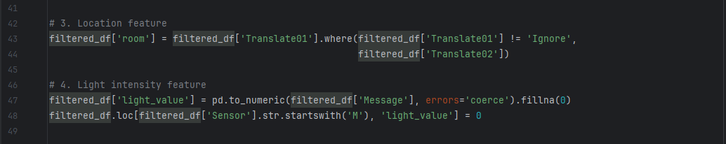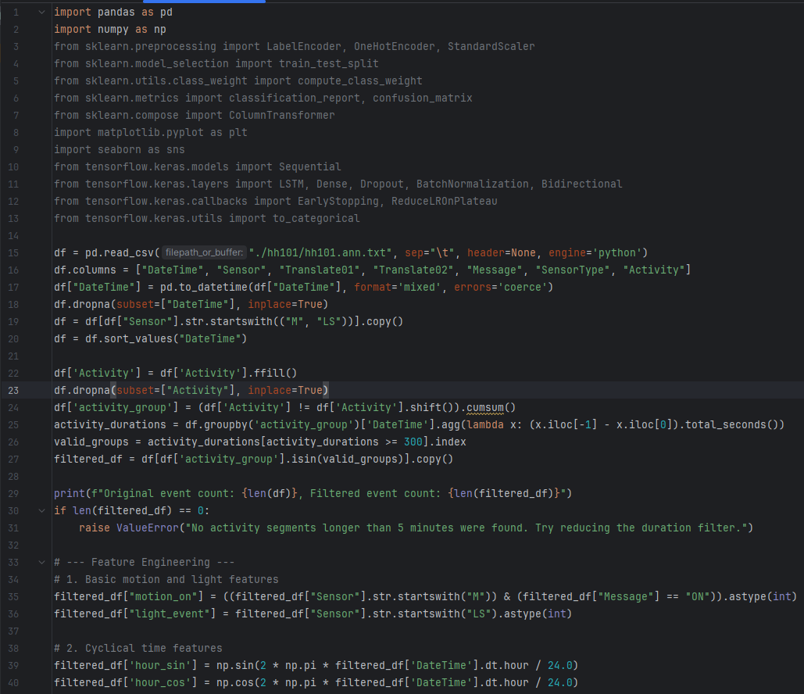**9.1 Data Preprocessing and Feature Engineering**

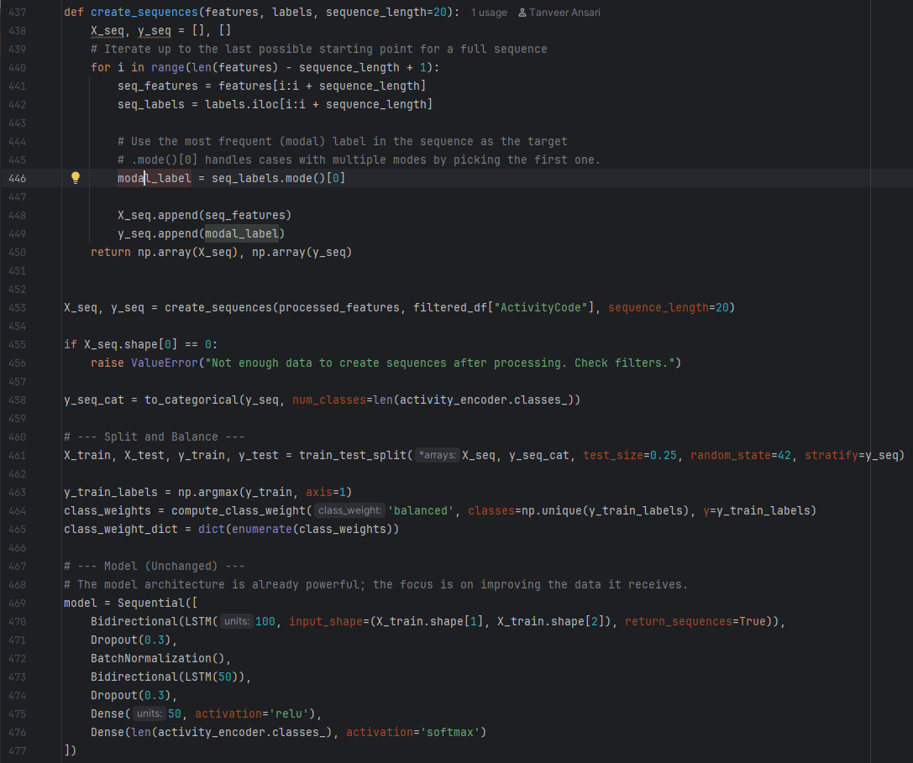**9.2 Bi-LSTM Model implementation**

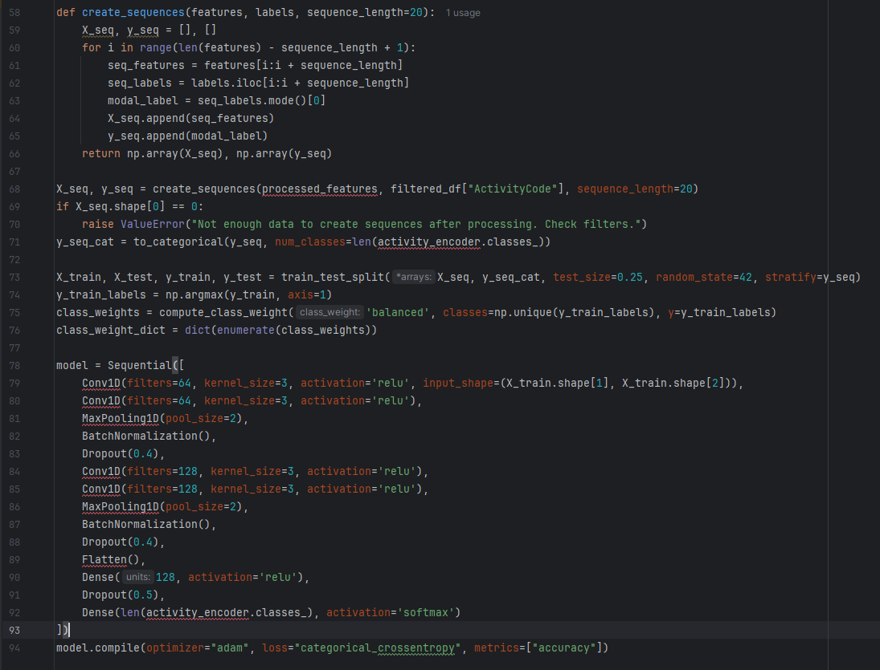**9.3 1D-CNN Model implementation**

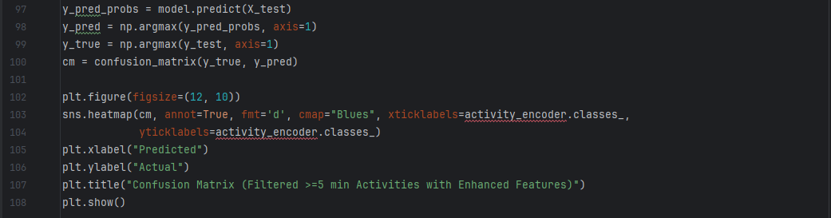**9.4 Model Evaluation and Visualization**

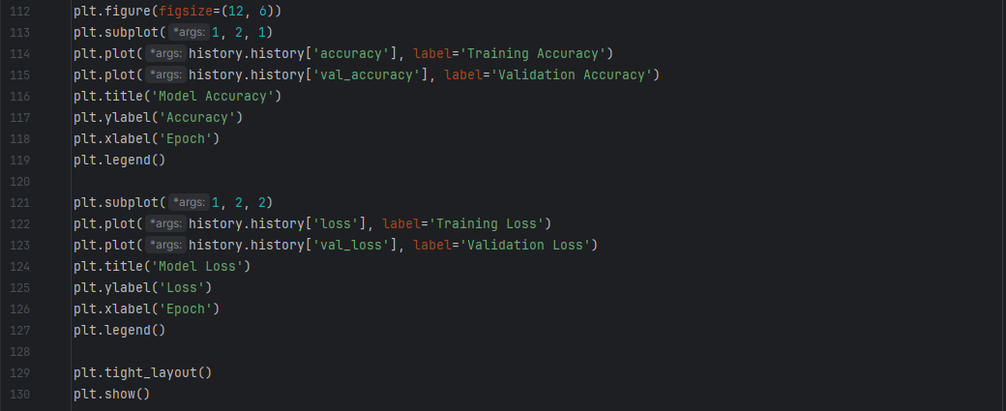**9.5 Comparative Visualization**